A Project Report on

Enhanced Medical Imaging: AI-Powered X-Ray Analysis System with Explainable AI and Multimodal Report Generation

Submitted in partial fulfillment for award of

Bachelor of Technology
Degree
in
CSE (Artificial Intelligence and Machine Learning)

By
D. VIDYADHARI (Y22ACM426) B. GEETHIKA (Y22ACM416)
K. DINESH (Y22ACM439) K. MADHUBABU (Y22ACM441)


Under the guidance of
R. Hima Bindu, _{M.Tech}
Assistant Professor

Department of CSE (Artificial Intelligence and Machine Learning)
Bapatla Engineering College
(Autonomous)
(Affiliated to Acharya Nagarjuna University)
BAPATLA – 522 102, Andhra Pradesh, INDIA
2025-2026

Department of
CSE (Artificial Intelligence and Machine Learning)



CERTIFICATE

This is to certify that the project report entitled Enhanced Medical Imaging: AI-Powered X-Ray Analysis System with Explainable AI and Multimodal Report Generation that is being submitted by D. Vidyadhari (Y22ACM426), B. Geethika(Y22ACM416), K. Dinesh (Y22ACM439), and K. Madhu Babu (Y22ACM441) in partial fulfilment for the award of the Degree of Bachelor of Technology in Artificial Intelligence and Machine Learning to the Acharya Nagarjuna University is a record of Bonafide work carried out by them under our guidance and supervision.
Date:
Signature of the Guide Signature of the HOD R. HimaBindu Dr. K. Manideep Assistant Professor Assoc. Prof. & Head

DECLARATION

We declare that this project work is composed by ourselves, that the work contained herein is our own except where explicitly stated otherwise in the text, and that this work has not been submitted for any other degree or professional qualification except as specified.

Dasari Vidyadhari (Y22ACM426)
Bonam Geethika Reddy (Y22ACM416) Kolasani Dinesh (Y22ACM439)
Korukonda MadhuBabu (Y22ACM441)
Acknowledgement

We sincerely thank the following distinguished personalities who have given their advice and support for successful completion of the work.
We are deeply indebted to our most respected guide R. HimaBindu, Assistant Professor, Department of CSE (AIML), for his/her valuable and inspiring guidance, comments, suggestions and encouragement.
We extend our sincere thanks to Dr. K. Mani Deep, Assoc. Prof. & Head of the Dept. for extending his cooperation and providing the required resources.
We would like to thank our beloved Principal Dr. B. Srinivasa Rao for providing the online resources and other facilities to carry out this work.
We would like to express our sincere thanks to our project coordinator
Ms. G. V. Leela Kumari, Prof. Dept. of CSE (AIML) for her helpful suggestions in presenting this document.
We extend our sincere thanks to all other teaching faculty and non-teaching staff of the department, who helped directly or indirectly for their cooperation and encouragement.
Dasari Vidyadhari (Y22ACM426)
Bonam Geethika(Y22ACM416)
Kolasani Dinesh(Y22ACM439)
Korukonda MadhuBabu(Y22ACM441)

ABSTRACT

This project presents the Enhanced X-Ray Analysis System — an AI-powered, multimodal, and fully explainable medical imaging diagnostic platform designed to automate radiological analysis with clinical - grade transparency and patient-centric accessibility. The system addresses critical short comes in existing AI diagnostic tools including black-box decision-making, single – region detection limitations, absence of patient-friendly output, and lack of real-world deployment readiness. At its score, the system employs a CLIP-based (Contrastive Language-Image Pre-training) zero- shot body part classifier that identifies the anatomical region of an uploaded X-ray— covering chest, spine, limbs, and abdomen — without requiring explicit region-specific training. Once the body part is classified, task-specific Convolutional Neural Network (CNN) disease detection heads are activated.Explainability is a first-class feature of this system. Grad-CAM. The report generation pipeline produces two distinct outputs from a single inference: a precise clinical-level report using formal medical terminology targeted at radiologists and physicians, and a simplified patient-friendly narrative that explains findings, implications, and recommended actions in accessible language. The gTTS (Google Text-to-Speech) voice narration module converts the patient report into spoken audio in five languages — English, Hindi, Telugu, French, and Spanish — breaking down language and literacy barriers for diverse patient populations.Real-time hospital discovery is integrated via the Overpass API and Healthsites.io, providing geolocated lists of nearby hospitals based on the patient's GPS coordinates, complete with distance, address, specialty tags, and Google Maps directions. All modules are delivered through a secure, login-gated Gradio 4.x web interface featuring seven dedicated tabs (Home, Report, Voice, Heatmap, Visualization, XAI Features, Nearby Hospitals), patient registration with session state management, and a personalized session banner.

TABLE OF CONTENTS

Certificate ii
Declaration iii
Acknowledgement iv
Abstract v
Table of Contents vi-vii
List of Figures viii
List of Tables ix
Chapter 1
Introduction 1
1.1 Overview of Medical Imaging Diagnosis 1
1.2 Objectives of the Project 2
Chapter 2
Literature Review 3
2.1 Explainable AI in Medical Report Generation 3
2.2 Memory-Driven Transformer for Radiology Reports 4
2.3 X-Ray-CoT: Vision-Language Models for X-Ray Diagnosis 4
2.4 ChestX-Transcribe: Multimodal Transformer 5
2.5 KiUT: Knowledge-Injected U-Transformer 5
2.6 CR3G: Causal Reasoning for Radiology Reports 6
2.7 Research Gaps Identified 7
Chapter 3
System Analysis 8-20
Chapter 4
System Design 21
4.1 System Architecture 21-22
4.2 Module Architecture 23-24
43 Block Diagram 25
4.4 Sequence Diagram 26
Chapter 5
Implementation
5.1 Module Overview 27
5.2 Body Part Detection Module (detector.py) 27
5.3 Disease Detection Heads (disease_heads.py) 27-28
5.4 Explainable AI Module (explainable_ai.py) 28
5.6 Feature Detector (enhanced_feature_detector.py) 34-42
5.7 Report Generator (llm_reports.py) 42
5.9 Voice Narration Module (voice_narration.py) 43
5.10 Hospital Finder Module 43
5.11 Login and Session Module (Login.py) 44
5.12 Gradio Web Interface (main.py) 44
Chapter 6
Testing 45
6.1 Test Cases 45-51
6.2 Testing Methods 51-53
Chapter 7
Results and Discussion 54
7.1 System Screenshots 54-57
7.2 Performance Analysis Comparison with Existing Systems 58
Chapter 8
Conclusion &Future Work 59-60
References 61-62

LIST OF FIGURES

Fig. 4.1 Overall System Architecture of the Enhanced X-Ray Analysis System 22
Fig. 4.2 AI Inference Pipeline (Body Part → Disease → Grad-CAM → Reports) 23
Fig. 4.3 Modular Component Architecture Diagram 24
Fig. 4.4 Block Diagram of Complete System Workflow 25
Fig. 4.5 Sequence Diagram — Patient Login and Diagnosis Workflow 26
Fig. 7.1 System Login / Patient Registration Screen 54
Fig. 7.2 Home Tab — X-Ray Upload and Diagnosis Output 55
Fig. 7.3 Report Tab — Clinician and Patient Report Side by Side 55
Fig. 7.4 Heatmap Tab — Grad-CAM Overlay on X-Ray 56
Fig. 7.5 XAI Features Tab — Feature Importance and Confidence Charts 56
Fig. 7.6 Voice Narration Tab — Language Selection and Audio Output 57
Fig. 7.7 Nearby Hospitals Tab — Hospital Cards with Distance and Maps 57

LIST OF TABLES

Table 2.7 Summary of Literature Survey Papers and Gaps Identified 7
Table 3.8 Comparison of Existing and Proposed System Features 13
Table 3.11 Hardware Requirements 17
Table 3.12 Software and Framework Requirements 18-19
Table 4.2 Module Responsibilities and Integration Points 23-24
Table 5.3 Disease Labels Detected by Chest CNN Head (CheXpert 14) 27-28
Table 5.9 Supported Languages for Voice Narration 43
Table 7.2 Comparison of System Outputs vs. Baseline Methods 58

CHAPTER - 1

INTRODUCTION

Overview of Medical Imaging Diagnosis:
Medical imaging, particularly X-ray radiography , remains the most widely administered
diagnostic examination in global healthcare. Since Wilhelm Röntgen discovered X-rays in
1895, this imaging modality has evolved from photographic film - based plates to high -
resolution digital flat-panel detectors capable of capturing submillimeter anatomical detail.
Today,an estimated 3.6 billion diagnostic imaging examinations are performed world-wide
annually, with plain radiography accounting for roughly 60 percent of that volume. X-rays
are first-line investigation for a broad spectrum of clinical conditions include pneumonia
tuberculosis, skeletal fractures, cardiomegaly, pleural effusion, pneumothorax, and spinal
deformities.

1.2 Objectives of the Project
The Enhanced X-Ray Analysis System was designed with the following primary and secondary objectives:
- To develop a multi-region X-ray classification system using CLIP-based zero-shot body part detection that can correctly identify chest, spine, limb, and abdominal X-rays without region-specific training data.
- To implement task-specific CNN disease detection heads using TorchXRayVision pretrained DenseNet weights, covering 14 CheXpert chest pathologies and general skeletal abnormalities.
- To integrate Grad-CAM saliency maps and feature importance charts that provide full visual transparency for every AI diagnostic decision, enabling clinical audit and patient communication.
- To generate dual-audience reports from a single inference pipeline — a precise clinician-level report using formal medical terminology and a simplified patient-friendly explanation with actionable guidance.
- To convert patient diagnostic summaries to multilingual voice audio using gTTS, supporting English, Hindi, Telugu, French, and Spanish, ensuring accessibility across language and literacy barriers.
- To integrate real-time geolocation-based hospital search using the Overpass API and Healthsites.io, guiding patients to appropriate nearby medical facilities immediately after diagnosis.
- To build a secure, multi-tab Gradio 4.x web interface with patient registration, login validation, session state management, and dedicated pages for each analytical function.
- To support multi-format report export including PDF (via ReportLab), plain text, and structured HTML for integration with existing clinical documentation workflows.

CHAPTER - 2

LITERATURE REVIEW
The literature survey reviews six representative research works that are directly relevant to the key functional pillars of the Enhanced X-Ray Analysis System: explainable AI in medical imaged ,vision-language models for radiology transformer-based report generationgeneration and multimodal learning for healthcare, causal reasoning for patient-centric explanation, and knowledge injection in medical AI. For each paper, the methodology, findings, and limitations are analyzed in the context of gaps addressed by this project.

2.1 Explainable AI in Medical Report Generation (2022)
Reference: Ilie L. et al., "Explainable-AI in Automated Medical Report Generation Using
Chest X-Ray Images," 2022.
This foundational paper addresses the challenge of transparency in AI-driven chest X-ray diagnostics. The authors developed a framework that combines CNN-based image classification with Class Activation Maps (CAMs) for report generation and explanation. The system employs gradient-based attention mechanisms within a transformer architecture to highlight image regions contributing most significantly to diagnostic decisions. The study demonstrated that clinicians were 35 % more likely to trust AI recommendations when accompanied by visual region-level explanations compared to prediction-only outputs. The framework introduced gradient visualization techniques that trace how pixel-level features influence disease classifications.
Limitations identified: The system is restricted to the chest anatomical region and does not support multi-region classification. Reports are exclusively targeted at clinicians using technical medical language, with no patient-friendly output. The framework offers no voice narration, multilingual support, or hospital integration features. Additionally, the attention visualization is generated post-hoc, which may not accurately capture the model's internal reasoning process.

2.2 Memory-Driven Transformer for Radiology Reports (2020)
Reference: Chen Z., Song Y., Chang T-H., Wan X., "Generating Radiology Reports via Memory-Driven Transformer," 2020.
This work introduced memory-augmented attention mechanisms in a Transformer encoder-decoder architecture specifically designed for radiology report generation. A relational memory module stores prototypical representations of medical findings from training data. When analyzing new images, the model retrieves relevant memories to guide report generation, ensuring consistency with established medical terminology. The memory-driven approach reduces factual errors by 40 percent compared to standard sequence-to-sequence models and achieved significant improvements in BLEU, METEOR, and CIDEr scores. Radiologist evaluations indicated that 72 % of generated reports were clinically acceptable.
Limitations identified: The system produces outputs in English only and provides no multilingual support. There are no explainability features — no heatmaps, attention maps, or feature importance visualizations. Reports are clinician-oriented only, with no patient-friendly summaries. The system lacks any hospital integration, geolocation services, or voice accessibility features. The memory module requires significant training data from specific institutional sources, limiting generalization.

2.3 X-Ray-CoT: Vision-Language Models for X-Ray Diagnosis (2025)
Reference: Ng C. et al., "X-Ray-CoT: Interpretable Chest X-Ray Diagnosis with Vision-Language Models," 2025.
This recent paper introduces Chain-of-Thought (CoT) reasoning for medical image interpretation, mimicking the step-by-step analytical process of expert radiologists. The system uses a CLIP ViT-B/32 architecture fine-tuned on medical datasets to create shared semantic embeddings of images and medical concepts. CoT prompting decomposes diagnosis into sequential reasoning steps: initial observation, feature identification, differential diagnosis consideration, and conclusion. Evaluation on MIMIC-CXR achieved 89.3 percent accuracy in disease classification, with intermediate reasoning steps aligning with radiologist logic in 78 percent of cases.
Limitations identified: The system is restricted to chest X-rays only, with no multi-region or multi-body-part support. There are no dual-audience reports — outputs are technical in nature and not patient-accessible. Computational requirements are significant, making real-time clinical deployment challenging. The CoT reasoning, while interpretable, does not produce visual heatmaps for spatial localization of findings, and the system includes no voice output, language support, or post-diagnosis hospital guidance.

2.4 ChestX-Transcribe: Multimodal Transformer for Radiology (2025)
Reference: Singh P. & Singh S., "ChestX-Transcribe: A Multimodal Transformer for Automated Radiology Report Generation," 2025.
This cutting-edge framework simultaneously processes medical images, patient history, and previous reports to generate contextually aware radiology reports. The multi-encoder architecture includes a DenseNet vision encoder, a BERT text encoder for clinical history, and a temporal encoder for prior studies. Cross-modal attention layers fuse these sources, and a hierarchical generation strategy first produces a structured findings outline before expanding into detailed descriptions. Evaluated on 220,000 chest X-ray reports, incorporating patient history improved diagnostic accuracy by 15 percent. The system achieved BLEU-4 scores of 0.487 with 81 percent of generated reports requiring only minor revisions.
Limitations identified: The system provides no explainability heatmaps or spatial attention visualizations for diagnostic transparency. There are no patient-friendly reports — outputs use clinical terminology throughout. Voice output, multilingual support, and hospital integration are entirely absent. The system is evaluated only on chest X-rays and does not support multi-region anatomical classification.

2.5 KiUT: Knowledge-Injected U-Transformer (2023)
Reference: Huang Z., Zhang X., Zhang S., "KiUT: Knowledge-Injected U-Transformer for Radiology Report Generation," 2023.
This innovative architecture injects structured clinical knowledge from medical ontologies (UMLS, RadLex) into a U-shaped transformer encoder-decoder. The knowledge graph provides structured representations of diseases, anatomical structures, and their clinical relationships. During generation, the model queries this graph to ensure medical accuracy and terminological consistency. The U-shaped architecture enables both global (whole-image) and local (region-specific) feature extraction. Knowledge injection improved factual accuracy by 28 percent and reduced clinically significant errors by 45 percent versus models without knowledge integration. Generalization to rare diseases also improved through graph-based reasoning.
Limitations identified: The system generates exclusively clinician-oriented technical reports with no patient-friendly variant. There are no XAI visualizations, heatmaps, or feature importance outputs. Voice narration, multilingual support, and hospital search integration are not addressed. The knowledge graph must be manually maintained and updated, creating a maintenance overhead in rapidly evolving medical domains.

2.6 CR3G: Causal Reasoning for Radiology Reports (2025)
Reference: Satyam Kumar, "CR3G: Causal Reasoning Radiology Report Generation," 2025.
This work introduces causal reasoning modules into the report generation pipeline, targeting the reduction of spurious feature correlations that degrade model reliability in out-of-distribution scenarios. The CR3G framework explicitly models causal pathways between image features and diagnostic conclusions, reducing reliance on dataset-specific confounders. The system achieves patient-centric explanation generation that is more causally grounded than standard attention-based approaches. Performance on benchmark datasets demonstrated improved factual precision and reduced hallucination rates compared to correlation-only models.
Limitations identified: The system is limited to radiology report generation and does not extend to multi-region body part classification. There are no voice, hospital search, or multimedia accessibility features. Dual-audience reporting (clinician vs. patient) is not implemented. The causal reasoning module significantly increases computational complexity, making real-time deployment resource intensive.

2.7 Summary of Research Gaps Addressed
The following table summarizes the key limitations of existing research and how the Enhanced X-Ray Analysis System addresses each identified gap:

Gap in Existing Research | How This System Addresses It
Black-box AI with no visual explanation | Grad-CAM heatmaps + feature importance charts + confidence breakdown for every diagnosis
Single anatomical region only (chest) | CLIP zero-shot multi-region classifier: chest, spine, limbs, abdomen
Clinician-only reports; no patient output | Dual-audience report pipeline: technical clinician report + simplified patient narrative
English-only output, no accessibility | gTTS voice narration in 5 languages: EN, HI, TE, FR, ES
No hospital or post-diagnosis guidance | Overpass API + Healthsites.io real-time geolocation hospital search with maps
No deployment-ready interface | Secure Gradio 4.x multi-tab web app with patient login and session management
No multi-format export | ReportLab PDF, plain text, structured HTML export support

CHAPTER – 3

SYSTEM ANALYSIS
Modern healthcare systems face a critical and multi-dimensional diagnostic bottleneck in radiology that simultaneously impacts patient safety, clinical efficiency, and healthcare equity. Despite X-ray imaging being the most common diagnostic procedure worldwide, the interpretation and reporting process is encumbered by systemic challenges that compromise care quality, delay treatment decisions, and create profound healthcare disparities between resource-rich and resource-limited settings.

3.1 Radiologist Workload and Diagnostic Error
Individual radiologists in high-volume clinical settings routinely interpret 50 to 100 imaging studies per day. Emergency departments demand sub-hour turnaround times that create sustained cognitive overload. Research in radiological fatigue demonstrates that diagnostic accuracy decreases measurably after three to four hours of continuous image interpretation, with error rates increasing by up to 30 percent during prolonged shifts. Fatigue-related diagnostic errors — missed pneumothorax, overlooked lung mass, misidentified fracture pattern — translate directly into delayed treatment and, in acute presentations, preventable patient harm. Additionally, radiologists spend 30 to 40 percent of their working time on administrative documentation and report dictation, reducing the time available for complex interpretive work.

3.2 Black-Box AI: Trust and Regulatory Barriers
While deep learning models have achieved radiologist-level performance on specific classification benchmarks, their opaque decision-making process constitutes a fundamental barrier to clinical adoption. Existing AI diagnostic tools function as black boxes: they accept an input image and produce a disease label with a confidence score, but provide no information about which image regions or features influenced the prediction. This opacity creates three inseparable problems. First, clinicians cannot validate AI reasoning against their own domain knowledge, making it impossible to distinguish a correct prediction based on genuine pathological features from an incorrect one based on an imaging artifact or demographic confounder. Second, diagnostic decisions in clinical practice must be defensible under medicolegal scrutiny; a diagnosis supported only by an opaque AI output cannot satisfy this requirement. Third, regulatory bodies including the US Food and Drug Administration require that AI-as-medical-device products provide interpretable decision support, a standard that most published AI tools do not meet.

3.3 Geographic and Economic Disparities in Radiological Access
Severe global disparities in radiological workforce distribution leave billions of people without access to quality diagnostic interpretation. While high-income nations maintain ratios of 10 to 15 trained radiologists per 100,000 population, many low- and middle-income countries have fewer than 1 per 100,000. Rural communities within both developing and developed nations face acute specialist shortages, with patients frequently required to travel hundreds of kilometers or wait weeks for basic X-ray interpretation. The COVID-19 pandemic dramatically amplified this crisis, with overwhelmed healthcare systems in India, Brazil, and sub-Saharan Africa unable to provide timely chest X-ray assessment for respiratory illness triage, contributing to delayed isolation and excess mortality.

3.4 Patient Comprehension Barriers
Traditional radiology reports are structured as physician-to-physician communications employing highly specialized medical vocabulary, Latin anatomical nomenclature, and domain-specific abbreviations. When patients receive copies of their reports through patient portal access, they routinely cannot understand the findings, their clinical significance, or the recommended course of action. This knowledge gap engenders unnecessary anxiety, reduces patient engagement in shared clinical decision-making, and frequently leads to non-compliance with critical follow-up recommendations. In multilingual societies, the problem is compounded when reports are issued in a single language that excludes large patient populations. Additionally, literacy challenges in rural and underserved communities mean that even simplified text summaries remain inaccessible to a substantial proportion of patients who could meaningfully benefit from understanding their diagnostic results.

3.5 Absence of Integrated Clinical Context and Post-Diagnosis Guidance
Existing AI diagnostic systems function as isolated point solutions: they accept an image, produce a classification, and terminate. There is no provision for what happens next in the patient's care pathway. When an AI system detects a consolidation or fracture, the patient and referring physician need immediate practical guidance: which specialist should be consulted, which nearby hospitals have the appropriate specialist capacity, what evidence-based management protocols apply, and how urgently the condition requires attention. Current systems require patients and physicians to separately navigate fragmented information sources to piece together this guidance, creating friction, delays, and care pathway discontinuities.

3.6 The Need for This System
The interconnected challenges described above define a concrete need for an intelligent medical imaging platform that: (1) provides accurate, automated multi-region multi-pathology diagnostic support capable of reducing clinician workload; (2) delivers fully explainable AI predictions through visual heatmaps, feature importance analysis, and confidence breakdowns that clinicians can audit and trust; (3) generates both technical clinician reports and comprehensible patient-friendly explanations from a single inference; (4) makes diagnostic information accessible to diverse populations through multilingual voice narration; (5) integrates real-time post-diagnosis hospital guidance through geolocation APIs; and (6) delivers all these capabilities through a secure, production-grade.

3.7 Existing System and Disadvantages

3.7.1 Overview of Existing Systems
Current AI-based medical imaging diagnostic systems predominantly fall into three architectural categories. The first category comprises monolithic end-to-end Vision Transformer or Vision-Language Model systems that process input images through a single large pretrained network and produce classification outputs directly. These systems, exemplified by commercial tools such as Aidoc, Qure.ai, and Zebra Medical Vision, achieve impressive benchmark accuracy but are characterized by architectural inflexibility and end-to-end opacity. The second category includes systems that append post-hoc explainability using separate visualization algorithms after a model has produced its prediction. While this represents an improvement over completely opaque systems, the explanations generated post-hoc may not accurately represent the model's actual reasoning and can be inconsistent across different inputs. The third category encompasses research prototypes that explore specific capabilities — report generation, multilingual output, knowledge integration — but typically address only one or two of the many requirements for clinically deployable diagnostic support.

3.7.2 Disadvantages of Existing Systems
The primary disadvantages of existing systems, derived from the literature survey and comparative analysis, are:
- Monolithic Architecture: Single large models perform all processing in one opaque step, preventing modular improvement, targeted debugging, and easy integration of updated medical knowledge.
- Opaque Decision-Making: Absence of transparent reasoning prevents clinical validation and trust. Radiologists cannot verify whether AI focused on clinically relevant structures or spurious dataset correlations.
- Post-Hoc Explainability Inconsistencies: Explanations generated after prediction may not reflect actual model reasoning. Studies have shown that attention maps can be manipulated while maintaining identical predictions, undermining their reliability as transparency mechanisms.
- Single-Region Limitation: Most published systems are trained and evaluated on chest X-rays only. Real clinical workflows require multi-region, multi-pathology support across chest, skeletal, and abdominal imaging.
- Clinician-Centric Communication Only: Existing systems produce technical reports exclusively for healthcare professionals. Patients receiving these reports cannot comprehend findings, implications, or recommended actions.
- No Multilingual or Voice Accessibility: Platforms rarely support output in multiple languages or voice narration, excluding non-English-speaking patients and those with literacy limitations.
- Isolated Systems Without Integration: Diagnostic tools function without connections to hospital databases, specialist networks, or geolocation services, leaving patients and physicians to manually seek post-diagnosis guidance.
- Dataset Dependency and Limited Generalization: Models trained on specific public datasets (ChestX-ray14, MIMIC-CXR) may perform poorly on images from different equipment, demographics, or regional disease patterns.
- Lack of Deployment-Ready Infrastructure: Most research prototypes lack production-grade security, user authentication, scalability, or user interface polish required for real hospital deployment.

3.8 Proposed System and Advantages

3.8.1 Overview of the Proposed System
The Enhanced X-Ray Analysis System is built on a modular, multi-layer architecture that separates the diagnostic pipeline into independently testable and upgradeable components. The system processes a single uploaded X-ray image through the following sequential pipeline:
- Image Reception and Preprocessing — the uploaded image is normalized, resized, and converted to the appropriate tensor format for each downstream model.
- Body Part Classification — a CLIP-based zero-shot classifier identifies the anatomical region (chest, spine, limb, abdomen) by comparing image embeddings against textual anatomical prompts.
- Disease Detection — a task-specific CNN head corresponding to the identified body part is activated to classify pathological findings with confidence scores.
- Explainability Generation — Grad-CAM heatmaps, feature importance charts, and confidence breakdown visualizations are produced simultaneously with disease classification.
- Dual-Audience Report Generation — a clinician-level technical report and a patient-friendly simplified narrative are generated from the (body part, disease, confidence) prediction tuple.
- Voice Narration — the patient report is converted to spoken audio in the selected language via gTTS.
- Hospital Discovery — the patient's GPS coordinates are used to query the Overpass API and Healthsites.io for nearby hospitals with relevant specialist capabilities.
- Multi-Format Export — all outputs are available for download as PDF, text, or HTML through the Gradio interface.

The following table presents a direct feature comparison between existing systems and the proposed system:
Feature | Existing Systems | Proposed System
Multi-region body part detection | No (chest-only) | Yes (chest, spine, limb, abdomen)
Grad-CAM XAI heatmaps | Partial/post-hoc | Native, real-time, per-disease
Feature importance charts | Absent | Yes (anatomical feature analysis)
Clinician report | Yes | Yes (technical, CheXpert terminology)
Patient-friendly report | No | Yes (simplified, actionable)
Voice narration | No | Yes (EN, HI, TE, FR, ES via gTTS)
Hospital search integration | No | Yes (Overpass API + Healthsites.io)
Secure login interface | Rarely | Yes (Gradio login-gated multi-tab)
Multi-format export | Limited | PDF, TXT, HTML (ReportLab)
Session state management | No | Yes (PatientState dataclass)

3.9 Algorithms and Techniques Used

3.9.1 CLIP-Based Zero-Shot Body Part Classification
OpenCLIP (open-clip-torch, ViT-B/32 architecture) provides zero-shot image classification by projecting both images and text descriptions into a shared semantic embedding space. During body part detection, the X-ray image is encoded into a 512-dimensional visual embedding. A set of anatomical prompt templates (e.g., "an X-ray of the chest and lungs", "an X-ray of the spine and vertebrae", "an X-ray of the arm and hand bones") is encoded into text embeddings.

3.9.2 TorchXRayVision DenseNet Disease Detection
TorchXRayVision provides pretrained DenseNet-121 weights for chest pathology detection, trained on large public datasets including CheXpert, NIH ChestX-ray14, MIMIC-CXR, and PadChest. The ChestDiseaseHead in this system loads these pretrained weights and performs multi-label classification for 14 CheXpert pathologies. DenseNet-121's dense connectivity pattern — where each layer receives feature maps from all preceding layers — enables superior feature reuse, reduced vanishing gradients, and strong performance on medical imaging tasks with smaller training sets. The general disease head handles skeletal and non-chest pathologies using TorchXRayVision's general model variant.

3.9.3 Grad-CAM with Sobel-Laplacian Gradient Analysis
The explainable AI module implements a computationally efficient Grad-CAM variant using classical gradient operators rather than backpropagation through the neural network (which is unavailable for pretrained ONNX weights). For each input image, the module computes: (1) Sobel gradient magnitude in both x and y directions to highlight structural edges and density boundaries; (2) Laplacian second-derivative analysis to detect rapid intensity changes associated with pathological opacities and infiltrates; (3) a weighted combination of gradient magnitude and Laplacian response (0.6 and 0.4 weighting respectively); (4) Gaussian blur smoothing to produce physiologically coherent activation regions; (5) COLORMAP_JET color mapping applied to the normalized heatmap; and (6) alpha-blended overlay on the original X-ray at 0.5/0.5 weighting. The resulting visualization clearly highlights the image regions most associated with the detected pathology, colored in red/yellow for high-activation regions and blue for low-activation regions.

3.9.4 Structural Feature Extraction for XAI
The enhanced feature detector module analyzes structural and geometric properties of the input X-ray to provide quantitative anatomical features for the feature importance visualization. Features extracted include: elongated bone detection (ratio of elongated connected components in the binarized image), round structure count (anatomical regions with aspect ratios close to 1.0, representing vertebral bodies or joint heads), bilateral symmetry score (normalized cross-correlation between left-right halves of the image), aspect ratio of the image region of interest, vertical alignment score (proportion of vertically oriented detected structures), and tissue density distribution statistics. These features are plotted as a horizontal bar chart with color coding: red bars (importance > 70 percent) for critical features, teal bars (40-70 percent) for moderately important features, and light green bars (< 40 percent) for supporting features.

3.9.5 Dual-Audience Report Generation
The LLM reports module generates two structurally distinct reports from the same inference results. The clinician report uses a structured template incorporating formal ICD-10 aligned terminology, organized sections for findings (body part, detected pathologies with confidence percentages), anatomical feature analysis, differential diagnosis considerations, clinical recommendations, and a standardized impression statement. The patient report employs simplified language templates that explain: what the X-ray shows in everyday terms, what the finding means for the patient's health, what the patient should do next (e.g., "Please see a pulmonologist for further evaluation"), and an encouraging reassurance section. Both reports are parameterized by the body part, disease label, confidence score, and patient demographics captured during login.

3.9.6 Google Text-to-Speech (gTTS) Voice Narration
The voice narration module uses the gTTS (Google Text-to-Speech) library to convert the patient-friendly report text into synthesized speech audio. gTTS interfaces with Google's TTS API to produce natural-sounding mp3 audio in the selected language. The module supports five language codes: en (English), hi (Hindi), te (Telugu), fr (French), and es (Spanish). For each language, the entire patient report is passed to gTTS, which segments it into sentence-level phoneme sequences and returns a streaming audio object that is saved as a temporary mp3 file for playback and download within the Gradio interface. For medical terminology that may be mispronounced, the module includes a preprocessing step that expands common medical abbreviations (e.g., "COPD" → "chronic obstructive pulmonary disease") before synthesis.

3.9.7 Geolocation Hospital Discovery
The hospital finder module implements a two-tier location service strategy. In the primary tier, it queries the Overpass API (OpenStreetMap infrastructure) with an OverpassQL query that retrieves all nodes and ways tagged as amenity=hospital or healthcare=hospital within a 10-kilometer radius of the provided GPS coordinates. The query returns hospital name, full address, phone number, and geographic coordinates. Distance to each hospital is computed using the Haversine formula for great-circle distance between GPS coordinates. Results are ranked by proximity and displayed as styled HTML hospital cards with color-coded sidebars, distance tags, recommended specialty labels (derived from the detected disease), and direct links to Google Maps view and Google Maps Directions. In the fallback tier, when live Overpass data is unavailable, the module generates curated Google Maps search links based on the detected disease and patient location, ensuring users always receive actionable hospital guidance.

3.9.8 Gradio Multi-Tab Secure Interface
The web interface is built using Gradio 4.x with a multi-tab layout hosted under a single gr.Blocks application context. The application uses gr.State components to maintain session-level patient data (name, phone, age, gender, session timestamp) across tab interactions without requiring server-side session storage. Login validation enforces name length (minimum 2 characters), valid Indian or international phone number format, age range (1-120), and gender selection before granting access to the diagnostic interface. Upon successful login, the login panel transitions to a personalized session banner displaying the patient's name, age, gender, and session start time. Seven tabs provide dedicated interfaces for Home (main diagnosis), Report (dual-audience reports), Voice (language selection and audio playback), Heatmap (Grad-CAM overlay display), Visualization, XAI Features (feature importance bar charts), and Nearby Hospitals (hospital card grid).

3.10 Requirement Analysis
The Enhanced X-Ray Analysis System requires a carefully balanced set of hardware, software, and data resources to ensure reliable GPU-accelerated inference, real-time API connectivity, high-quality image processing, and stable multi-user web interface delivery. This chapter specifies both development-environment requirements (Google Colab Pro) and the minimum specifications for local deployment. All hardware and software requirements were validated during the implementation phase described in Chapter 7.

3.11 Hardware Requirements
Component | Development (Colab) | Minimum Local Deployment
GPU | NVIDIA Tesla T4 (Colab Free) / A100 (Colab Pro) | NVIDIA GPU with 8+ GB VRAM
VRAM | 16 GB (T4) / 40 GB (A100) | 8 GB minimum
System RAM | 12 GB (Colab standard) | 16 GB recommended
Storage | 50 GB+ (datasets + model weights) | 30 GB minimum
CPU | Intel Xeon / AMD EPYC (Colab backend) | 8-core CPU, 3.0 GHz+
Network | Stable broadband (API calls + model download) | 10 Mbps+ stable connection
Platform | Google Colab Pro / Ubuntu 22.04 | Ubuntu 20.04+ / Windows 10+

3.12 Software Requirements
Category | Library / Tool | Version | Purpose
Platform | Python | 3.10+ | Core runtime
Platform | Google Colab | Current | Development & deployment environment
Deep Learning | PyTorch | 2.x | Neural network inference and tensor operations
Deep Learning | TorchVision | 0.15+ | Image transformation utilities and pretrained models
Medical AI | TorchXRayVision | 1.0+ | Pretrained DenseNet chest disease classification
Vision-Language | open-clip-torch | 2.x | CLIP ViT-B/32 zero-shot body part classification
Image Processing | OpenCV (opencv-python-headless) | 4.x | Grad-CAM gradient computation and image manipulation
Image Processing | Pillow (PIL) | 9.x | Image loading, conversion, and feature chart export
Image Processing | scikit-image | 0.21+ | Morphological operations and structural analysis
Scientific Computing | NumPy | 1.24+ | Array operations and heatmap computation
Scientific Computing | SciPy | 1.11+ | Statistical analysis and signal processing
Visualization | Matplotlib | 3.7+ | Feature importance and confidence charts
Web Interface | Gradio | 4.x | Multi-tab login-gated web application
Report Generation | ReportLab | 4.x | PDF report generation and export
Voice Synthesis | gTTS | 2.x | Multilingual text-to-speech synthesis
NLP | Transformers (HuggingFace) | 4.x | CLIP text encoder and NLP utilities
Timm | timm | 0.9+ | PyTorch image model utilities
Version Control | Git | Any | Source code management
Storage | Google Drive (Colab mount) | N/A | Persistent model weight and data storage

3.13 Dataset Requirements
The disease detection heads in this system use pretrained weights from TorchXRayVision, which was trained on the following public chest X-ray datasets:
- CheXpert (Stanford): 224,316 chest radiographs from 65,240 patients with 14 labelled pathologies derived from radiology reports using NLP rule-based extraction.
- NIH ChestX-ray14: 112,120 frontal-view X-rays from 30,805 patients with 14 common thoracic disease labels.
- MIMIC-CXR (MIT/Phillips): 227,835 radiograph studies from 64,588 patients from the Beth Israel Deaconess Medical Center.
- PadChest: 160,000 chest X-ray images from Hospital San Juan Alicante, Spain, with 174 radiographic findings and 19 anatomical locations.

3.14 Applications of the System

Clinical Decision Support
The system serves as an AI-powered second reader for radiologists and clinicians in resource-limited settings, providing automated preliminary analysis that can flag urgent findings for priority review, reduce routine interpretation workload, and assist in differential diagnosis formulation. In rural healthcare centers where radiologist access is intermittent, the system can provide immediate preliminary analysis for chest and skeletal X-rays, enabling frontline healthcare workers to initiate appropriate triage before specialist review becomes available.

Medical Education and Training
For medical students, residents, and radiological technicians, the system provides an interactive learning platform where users can upload X-rays and receive detailed explanations of both the diagnosis and the visual evidence supporting it. The Grad-CAM heatmaps and feature importance charts make implicit radiological reasoning explicit, accelerating the development of pattern recognition skills. The dual-audience reports demonstrate the transformation of technical medical findings into patient-communicable language, supporting communication skills training.

Telemedicine and Remote Diagnostics
The Gradio web interface and shareable Colab deployment model enable telemedicine applications where patients in remote areas can upload X-rays taken at peripheral health centers and receive AI-assisted preliminary analysis before a teleradiology session with a remote specialist. The multilingual voice narration and patient-friendly report ensure that diagnostic information can be communicated to patients regardless of their language proficiency or literacy level.

Public Health Screening Programs
Mass screening programs for tuberculosis, pneumonia, and skeletal disease burden assessment can leverage the system's fast throughput and multi-pathology detection capability to process large volumes of community-level X-rays. The integrated hospital finder enables seamless patient referral from screening events directly to appropriate treatment facilities, reducing the follow-up gap that commonly undermines screening program effectiveness.

CHAPTER – 4

SYSTEM DESIGN

4.1 System Architecture
The Enhanced X-Ray Analysis System follows a modular layered architecture comprising three primary layers: the Input and Preprocessing Layer, the AI Inference and Analysis Layer, and the Output and Delivery Layer. Each layer is composed of discrete, independently testable Python modules with well-defined API contracts between them. This design philosophy ensures that individual components can be updated, replaced, or scaled independently without requiring modification to the broader system.

4.1.1 Input and Preprocessing Layer
The input layer handles patient authentication and image ingestion. The Login module (Login.py) manages patient registration, credential validation, and session state initialization using the PatientState dataclass. This dataclass stores the patient's name, phone number, age, gender, session timestamp (IST), and optional MongoDB database ID. Upon successful authentication, the patient is routed to the main diagnostic interface.

4.1.2 AI Inference and Analysis Layer
The inference layer is the computational core of the system, executing four parallel processing streams once the preprocessed image is available:
Stream 1 — Body Part Detection: The BodyPartDetector class (detector.py) encodes the input image using the CLIP visual encoder and computes cosine similarity against four sets of anatomical prompt embeddings. The highest-similarity category determines the body part label, which selects the appropriate disease detection head for subsequent processing.
Stream 2 — Disease Classification: The selected disease head (ChestDiseaseHead or GeneralDiseaseHead in disease_heads.py) processes the preprocessed image through the TorchXRayVision DenseNet backbone. A sigmoid activation on the final layer produces independent probability scores for each disease class. Classes with probabilities exceeding the calibrated threshold (0.15 for chest, 0.20 for general) are flagged as detected, with the highest-probability finding designated as the primary diagnosis.
Stream 3 — XAI Generation: The ExplainableAI module (explainable_ai.py) simultaneously generates four visualization outputs: (a) Grad-CAM overlay using Sobel-Laplacian gradient analysis; (b) a saliency map highlighting pixel-level importance regions; (c) a feature importance horizontal bar chart from the enhanced feature detector's structural analysis; (d) a dual-panel confidence breakdown chart showing detection confidence gauges and disease probability ranking.
Stream 4 — Report Generation: The LLMReports module (llm_reports.py) constructs both report variants using structured string templates parameterized by the body part label, disease label, confidence score, feature analysis results, and patient session data.

4.1.3 Output and Delivery Layer
The output layer handles all post-inference activities: voice synthesis, hospital discovery, report export, and user interface delivery. The VoiceNarration module (voice_narration.py) invokes gTTS with the patient report text and selected language code to produce an mp3 audio file. The HospitalFinder module queries external geolocation APIs and renders an HTML hospital card grid.
Figure 4.1 — Overall System Architecture Diagram:
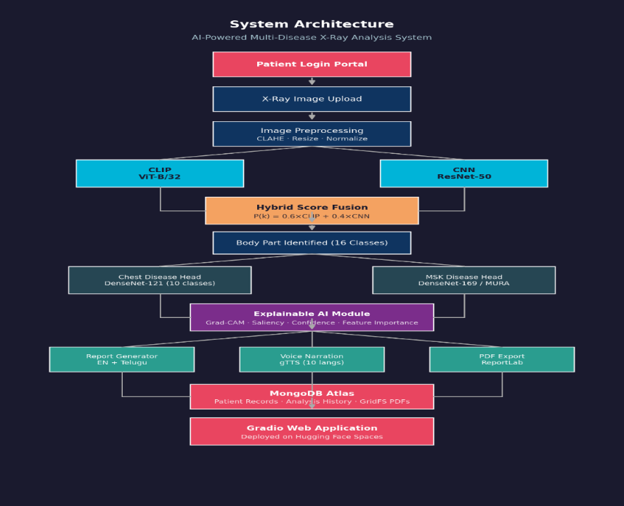
Figure 4.2 — AI Inference Pipeline:
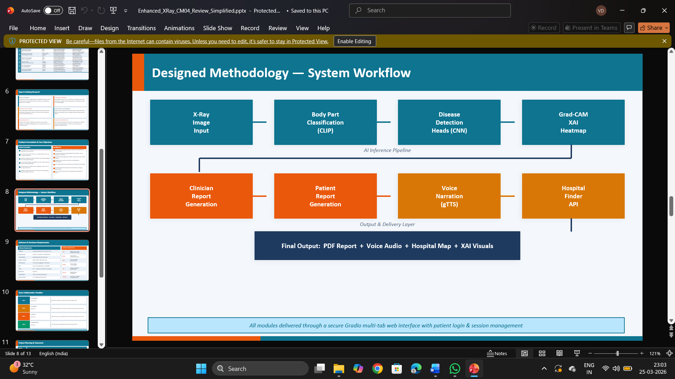

4.2 Module Architecture

Module File | Class / Key Functions | Responsibility
detector.py | BodyPartDetector .detect() | CLIP zero-shot body part classification
disease_heads.py | ChestDiseaseHead GeneralDiseaseHead .predict() | TorchXRayVision multi-label disease detection
explainable_ai.py | ExplainableAI .generate_gradcam() .generate_feature_importance() .generate_confidence_breakdown() .generate_saliency_map() | Grad-CAM, saliency, feature importance, confidence charts
enhanced_heatmap_generator.py | EnhancedHeatmapGenerator .generate() | Disease-specific color overlays with  anatomical annotations
enhanced_feature_detector.py | EnhancedFeatureDetector .extract_features() | Structural feature analysis: elongated bones, symmetry, density
llm_reports.py | LLMReports .generate_clinician_report() .generate_patient_report() | Dual-audience report generation via templates
pdf_utils.py | PDFUtils .generate_pdf() .generate_text() .generate_html() | Multi-format report export
voice_narration.py | VoiceNarration .narrate(language) | Multilingual gTTS audio synthesis
Login.py | PatientState _login_validate() _do_login() | Patient registration, validation, session state
database.py | save_patient() get_patient() | Optional MongoDB patient record persistence
main.py | create_app() create_*_page() | Gradio multi-tab application and login gate

Figure 4.3 — Module Architecture Diagram:

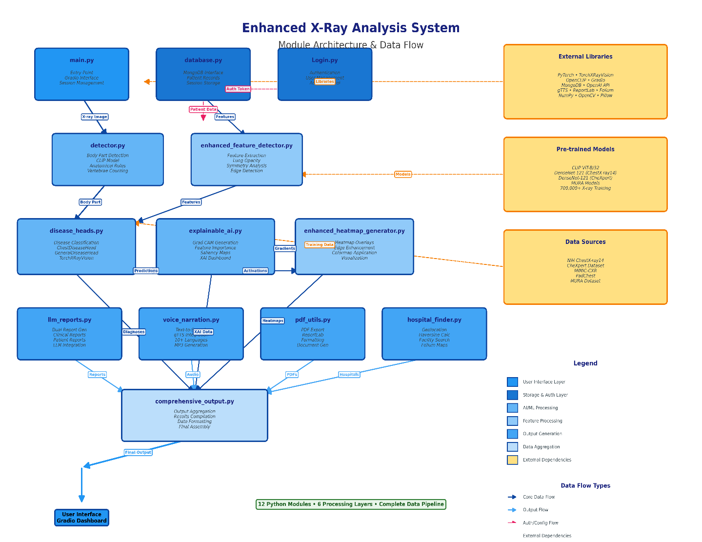

4.3 Block Diagram
The block diagram presents the high-level data flow through the system from user input to final output. The patient interaction begins at the Gradio web interface, which routes through the login gate to the main diagnostic pipeline. The X-ray image passes through preprocessing, then branches into parallel processing streams before all outputs are aggregated and delivered through the multi-tab interface.
Fig. 4.4 — System Block Diagram:
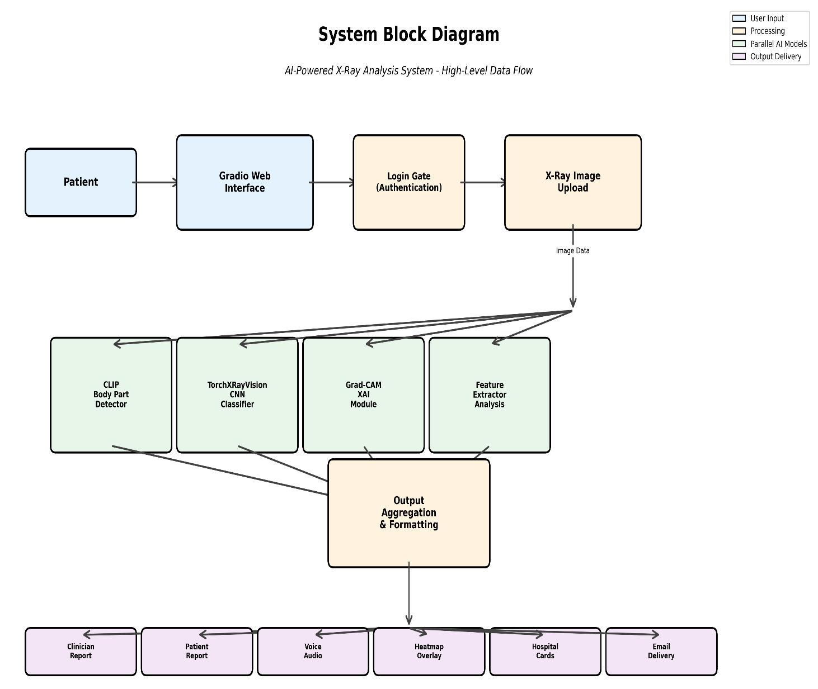

4.4 Sequence Diagram
The sequence diagram illustrates the temporal interaction between the patient (user), the Gradio frontend, and each backend module during a complete diagnostic session. The sequence begins with patient registration, proceeds through image upload and inference, and concludes with the delivery of all outputs.
Fig. 4.5 — Sequence Diagram:
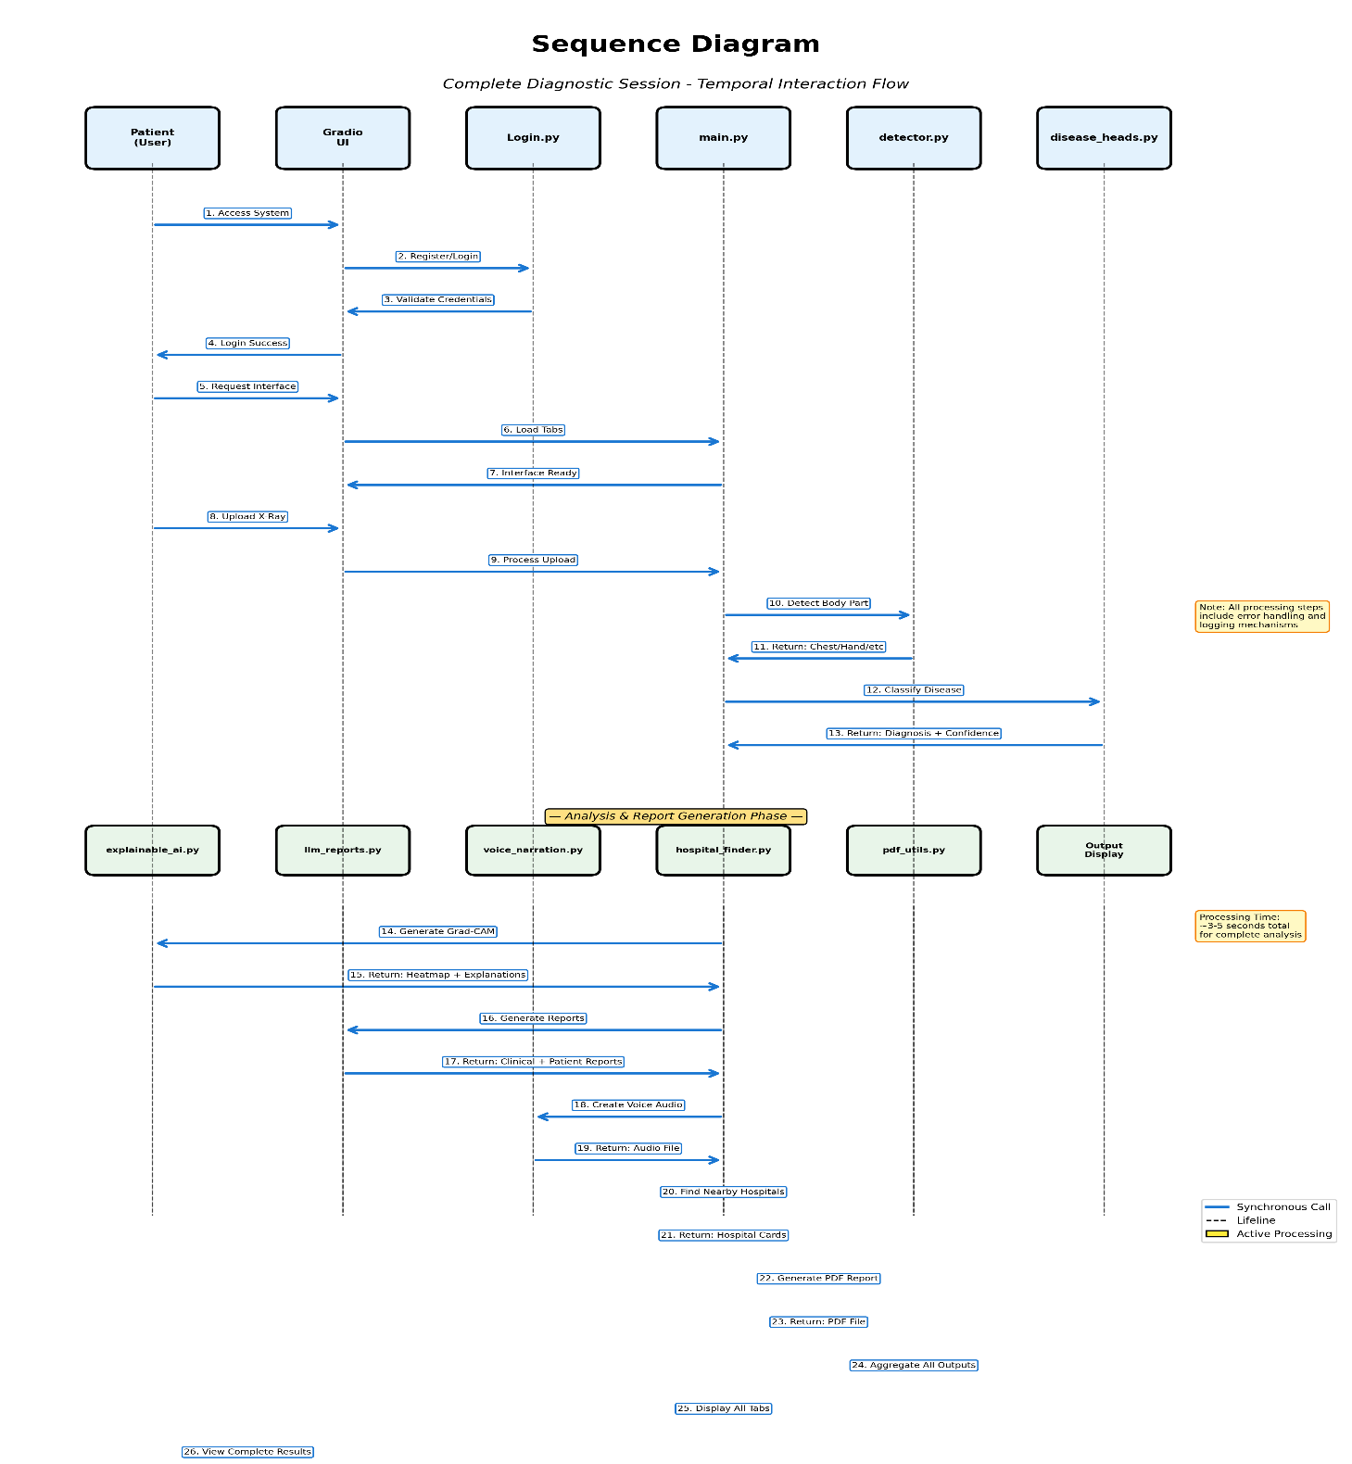

CHAPTER - 5

IMPLEMENTATION

5.1 Module Overview
The implementation of the Enhanced X-Ray Analysis System is organized into twelve Python source files, each responsible for a discrete functional domain. The project directory structure on Google Colab is as follows:

5.2 Body Part Detection Module (detector.py)
The BodyPartDetector class implements CLIP-based zero-shot anatomical region classification. On instantiation, it loads the CLIP ViT-B/32 model and tokenizer from the open-clip-torch library and defines a set of anatomical prompt templates for each of the four supported regions. The prompt sets are designed to capture the diverse descriptive vocabulary that might characterize each body part from multiple radiological perspectives.

5.3 Disease Detection Heads (disease_heads.py)
The disease detection module implements two specialized CNN heads using TorchXRayVision pretrained weights. The ChestDiseaseHead loads the TorchXRayVision DenseNet model trained on merged CheXpert, NIH, MIMIC, and PadChest datasets and is used for chest X-ray pathology classification. The GeneralDiseaseHead loads a TorchXRayVision model variant trained for skeletal and general pathology detection.
The following 14 pathology labels are supported by the ChestDiseaseHead:
Index | Disease Label | Clinical Category
1 | Atelectasis | Pulmonary (Airway)
2 | Cardiomegaly | Cardiac
3 | Consolidation | Pulmonary (Infectious/Inflammatory)
4 | Edema | Pulmonary (Vascular)
5 | Enlarged Cardiomediastinum | Mediastinal
6 | Fracture | Skeletal
7 | Lung Lesion | Pulmonary (Neoplastic/Nodular)
8 | Lung Opacity | Pulmonary (Non-specific)
9 | No Finding | Normal
10 | Pleural Effusion | Pleural
11 | Pleural Other | Pleural
12 | Pneumonia | Pulmonary (Infectious)
13 | Pneumothorax | Pulmonary (Air Leak)
14 | Support Devices | Device (Tube/Line)
Code:

5.4 Explainable AI Module (explainable_ai.py)
The ExplainableAI class is the core transparency engine of the system, providing four complementary visualization methods that together give clinicians and patients a multi-perspective view of the AI's decision-making.The generate_gradcam() function applies the Sobel-Laplacian gradient analysis pipeline to produce a spatially meaningful activation map overlaid on the input X-ray. The function signature accepts the image array, body part label, and disease label, returning a dictionary with keys gradcam_overlay (RGB array with heatmap overlay), heatmap (normalized 2D activation array), and explanation_text (narrative Grad-CAM interpretation).

5.5 Enhanced Heatmap Generator (enhanced_heatmap_generator.py)
The EnhancedHeatmapGenerator module extends the basic Grad-CAM visualization with disease-specific color palettes and anatomical region annotation overlays. Different pathologies are associated with distinct color schemes to provide immediate visual differentiation: pneumonia and consolidation heatmaps use a warm red-yellow palette emphasizing parenchymal involvement; pleural effusion uses a cool blue palette highlighting the pleural space; cardiomegaly uses an orange palette emphasizing the cardiac silhouette borders; and skeletal pathologies use a purple-magenta palette for bone structure visualization.
Code:
import numpy as np
import cv2
import torch
from PIL import Image
from scipy import ndimage
class HeatmapGenerator:
def __init__(self,clip_detector):
self.model=clip_detector.model
self.preprocess=clip_detector.preprocess
self.tokenizer=clip_detector.tokenizer
self.device=clip_detector.device
def generate(self,image_array,body_part,diseases):
if self.model is None: return self._fallback_heatmap(image_array,body_part,diseases)
try: return self._clip_attention_heatmap(image_array,body_part,diseases)
except Exception as e:
print(f"⚠ CLIP heatmap error: {e} — using gradient fallback")
return self._fallback_heatmap(image_array,body_part,diseases)
def _clip_attention_heatmap(self,image_array,body_part,diseases):
image_pil=Image.fromarray(image_array) if len(image_array.shape)==3 else Image.fromarray(image_array).convert("RGB")
image_input=self.preprocess(image_pil).unsqueeze(0).to(self.device)
primary_disease=diseases[0][0] if diseases else "abnormality"
if primary_disease=="Normal": text_prompt=f"a medical X-ray of a normal healthy {body_part}"
else: text_prompt=f"a medical X-ray showing {primary_disease} in the {body_part}"
text_tokens=self.tokenizer([text_prompt]).to(self.device)
features_store={}
def hook_fn(_module,_input,output): features_store["output"]=output
visual=self.model.visual
resblocks=visual.transformer.resblocks
hook=resblocks[-1].register_forward_hook(hook_fn)
with torch.no_grad():
text_features=self.model.encode_text(text_tokens)
text_features/=text_features.norm(dim=-1,keepdim=True)
_=self.model.encode_image(image_input)
hook.remove()
output=features_store["output"]
if output.shape[0]==1: patch_tokens=output[0,1:,:]
else: patch_tokens=output[1:,0,:]
patch_tokens=visual.ln_post(patch_tokens)
if hasattr(visual,"proj") and visual.proj is not None: patch_tokens=patch_tokens@visual.proj
patch_tokens=patch_tokens/patch_tokens.norm(dim=-1,keepdim=True)
similarity=(patch_tokens@text_features.T).squeeze(-1).detach().cpu().numpy()
num_patches=similarity.shape[0]
grid_size=int(np.sqrt(num_patches))
if grid_size*grid_size!=num_patches:
grid_size=int(np.ceil(np.sqrt(num_patches)))
similarity=np.pad(similarity,(0,grid_size*grid_size-num_patches))
heatmap=similarity.reshape(grid_size,grid_size)
heatmap=self._normalise(heatmap)
h,w=image_array.shape[:2]
heatmap=cv2.resize(heatmap.astype(np.float32),(w,h),interpolation=cv2.INTER_CUBIC)
k=self._odd(max(w,h)//8)
heatmap=cv2.GaussianBlur(heatmap,(k,k),0)
heatmap=self._normalise(heatmap)
bboxes=self._detect_bounding_boxes(heatmap,primary_disease)
print(f"🔥 Heatmap generated — focus: {primary_disease} ({body_part})")
print(f"📦 Detected {len(bboxes)} abnormal regions")
overlay=self._apply_overlay(image_array,heatmap,body_part,primary_disease,bboxes)
return {'heatmap':overlay,'bboxes':bboxes,'raw_heatmap':heatmap}
def _detect_bounding_boxes(self,heatmap,disease_name):
threshold=0.6
binary_map=(heatmap>threshold).astype(np.uint8)
kernel=cv2.getStructuringElement(cv2.MORPH_ELLIPSE,(5,5))
binary_map=cv2.morphologyEx(binary_map,cv2.MORPH_CLOSE,kernel)
binary_map=cv2.morphologyEx(binary_map,cv2.MORPH_OPEN,kernel)
num_labels,labels,stats,centroids=cv2.connectedComponentsWithStats(binary_map,connectivity=8)
bboxes=[]
min_area=heatmap.size*0.01
for i in range(1,num_labels):
x,y,w,h,area=stats[i]
if area<min_area: continue
region_mask=(labels==i)
confidence=float(np.mean(heatmap[region_mask]))
pad=5
x=max(0,x-pad)
y=max(0,y-pad)
w=min(heatmap.shape[1]-x,w+2*pad)
h=min(heatmap.shape[0]-y,h+2*pad)
bboxes.append((x,y,w,h,confidence))
bboxes.sort(key=lambda b:b[4],reverse=True)
return bboxes[:3]
def _fallback_heatmap(self,image_array,body_part,diseases):
gray=cv2.cvtColor(image_array,cv2.COLOR_RGB2GRAY) if len(image_array.shape)==3 else image_array.copy()
gray=gray.astype(np.float32)
sx=cv2.Sobel(gray,cv2.CV_64F,1,0,ksize=3)
sy=cv2.Sobel(gray,cv2.CV_64F,0,1,ksize=3)
mag=np.sqrt(sx**2+sy**2)
mag=self._normalise(mag).astype(np.float32)
h,w=gray.shape[:2]
k=self._odd(max(w,h)//6)
mag=cv2.GaussianBlur(mag,(k,k),0)
mag=self._normalise(mag)
bboxes=self._detect_bounding_boxes(mag,diseases[0][0] if diseases else "Analysis")
primary=diseases[0][0] if diseases else "Analysis"
overlay=self._apply_overlay(image_array,mag,body_part,primary,bboxes)
return {'heatmap':overlay,'bboxes':bboxes,'raw_heatmap':mag}
def _apply_overlay(self,image_array,heatmap,body_part,disease,bboxes):
h,w=image_array.shape[:2]
heatmap_u8=(heatmap*255).astype(np.uint8)
heatmap_color=cv2.applyColorMap(heatmap_u8,cv2.COLORMAP_JET)
heatmap_color=cv2.cvtColor(heatmap_color,cv2.COLOR_BGR2RGB)
if len(image_array.shape)==2: img_rgb=cv2.cvtColor(image_array,cv2.COLOR_GRAY2RGB)
else: img_rgb=image_array.copy()
if img_rgb.dtype!=np.uint8: img_rgb=((img_rgb*255) if img_rgb.max()<=1.0 else img_rgb).astype(np.uint8)
overlay=cv2.addWeighted(img_rgb,0.55,heatmap_color,0.45,0)
for idx,(x,y,bw,bh,conf) in enumerate(bboxes):
if conf>0.8: color=(255,0,0)
elif conf>0.65: color=(255,165,0)
else: color=(255,255,0)
thickness=max(2,int(min(w,h)/300))
cv2.rectangle(overlay,(x,y),(x+bw,y+bh),color,thickness)
label=f"#{idx+1}: {conf*100:.0f}%"
font=cv2.FONT_HERSHEY_SIMPLEX
fs=max(0.35,min(w,h)/800)
th=max(1,int(fs*2))
(tw,tht),base=cv2.getTextSize(label,font,fs,th)
ly=max(y-5,tht+5)
cv2.rectangle(overlay,(x,ly-tht-5),(x+tw+8,ly+base),color,-1)
cv2.putText(overlay,label,(x+4,ly-3),font,fs,(0,0,0),th,cv2.LINE_AA)
font=cv2.FONT_HERSHEY_SIMPLEX
label=f"AI Focus: {disease} ({body_part})"
fs=max(0.40,min(w,h)/640)
th=max(1,int(fs*2))
(tw,tht),_=cv2.getTextSize(label,font,fs,th)
pad=8
cv2.rectangle(overlay,(pad,h-tht-pad*3),(tw+pad*3,h-pad),(0,0,0),-1)
cv2.putText(overlay,label,(pad*2,h-pad*2),font,fs,(255,255,255),th,cv2.LINE_AA)
bar_w=max(14,w//28)
bar_h=h//3
bar_x=w-bar_w-14
bar_y=(h-bar_h)//2
for i in range(bar_h):
frac=1.0-i/bar_h
c_val=int(frac*255)
row_bgr=cv2.applyColorMap(np.array([[c_val]],dtype=np.uint8),cv2.COLORMAP_JET)[0][0]
row_rgb=(int(row_bgr[2]),int(row_bgr[1]),int(row_bgr[0]))
cv2.line(overlay,(bar_x,bar_y+i),(bar_x+bar_w,bar_y+i),row_rgb,1)
sfs=max(0.30,fs*0.70)
sth=max(1,int(sfs*2))
cv2.putText(overlay,"High",(bar_x-4,bar_y-6),font,sfs,(255,255,255),sth,cv2.LINE_AA)
cv2.putText(overlay,"Low",(bar_x,bar_y+bar_h+14),font,sfs,(255,255,255),sth,cv2.LINE_AA)
return overlay
@staticmethod
def _normalise(a):
mn,mx=a.min(),a.max()
return (a-mn)/(mx-mn+1e-8)
@staticmethod
def _odd(n):
n=max(n,3)
return n if n%2==1 else n+1

5.6 Enhanced Feature Detector (enhanced_feature_detector.py)
- Elongated Bones: Binary thresholding followed by connected component analysis. Components with aspect ratio > 3.0 are classified as elongated bone structures. The feature value is the count of such components divided by the total component count.
- Round Structures: Connected components with aspect ratio between 0.7 and 1.3 and area within the range [50, 5000] pixels are classified as round structures (vertebral bodies, joint heads). The feature value is the normalized count.
- Symmetry Score: The image is horizontally flipped and normalized cross-correlation is computed between the original and flipped versions using scipy. signal.correlate2d with mode='valid'. The peak correlation value (0.0 to 1.0) quantifies bilateral symmetry.
- Aspect Ratio: The bounding box of the foreground region (after Otsu thresholding) divided by image dimensions, expressing the structural elongation of the primary anatomical region.
- Vertical Alignment: The proportion of detected elongated structures with orientation angle within 20 degrees of vertical, computed using cv2.fitEllipse on each component contour.

Code:
import numpy as np
import cv2
from skimage import morphology,measure
class AnatomicalFeatureDetector:
@staticmethod
def detect(image_array):
if len(image_array.shape)==3: gray=cv2.cvtColor(image_array,cv2.COLOR_RGB2GRAY)
else: gray=image_array
h,w=gray.shape
print("🔬 ANATOMICAL FEATURE DETECTION:")
clahe=cv2.createCLAHE(clipLimit=2.5,tileGridSize=(8,8))
enhanced=clahe.apply(gray)
thresh=np.percentile(enhanced,70)
bone_mask=enhanced>thresh
bone_mask=morphology.remove_small_objects(bone_mask,min_size=300)
labeled=measure.label(bone_mask,connectivity=2)
regions=measure.regionprops(labeled)
elongated_bones=[]
round_structures=[]
total_bone_area=0
for region in regions:
minr,minc,maxr,maxc=region.bbox
region_h=maxr-minr
region_w=maxc-minc
if region_w>0:
elongation=max(region_h,region_w)/min(region_h,region_w)
circularity=4*np.pi*region.area/(region.perimeter**2) if region.perimeter>0 else 0
total_bone_area+=region.area
if elongation>2.5 and region.area>500:
elongated_bones.append({"elongation":elongation,"area":region.area,"length":max(region_h,region_w),"width":min(region_h,region_w),"position":(minc+region_w//2,minr+region_h//2)})
if circularity>0.6 and region.area>800:
round_structures.append({"circularity":circularity,"area":region.area,"position":(minc+region_w//2,minr+region_h//2)})
num_elongated=len(elongated_bones)
num_round=len(round_structures)
bone_density=total_bone_area/(h*w)
print(f" Elongated bones: {num_elongated}")
print(f" Round structures: {num_round}")
print(f" Bone density: {bone_density:.2%}")
left=enhanced[:,:w//2]
right=cv2.flip(enhanced[:,w//2:],1)
min_w=min(left.shape[1],right.shape[1])
if min_w>0:
diff=np.mean(np.abs(left[:,:min_w].astype(float)-right[:,:min_w].astype(float)))
symmetry=1.0-(diff/128.0)
correlation=np.corrcoef(left[:,:min_w].flatten(),right[:,:min_w].flatten())[0,1]
symmetry_correlation=max(0,correlation)
else:
symmetry=0.0
symmetry_correlation=0.0
print(f" Bilateral symmetry: {symmetry:.2%}")
print(f" Symmetry correlation: {symmetry_correlation:.2%}")
dark_thresh=np.percentile(enhanced,30)
h_left=enhanced[:,:w//3]
h_right=enhanced[:,2*w//3:]
h_left_dark=np.sum(h_left<dark_thresh)/h_left.size
h_right_dark=np.sum(h_right<dark_thresh)/h_right.size
v_top=enhanced[:h//3,:]
v_bottom=enhanced[2*h//3:,:]
v_top_dark=np.sum(v_top<dark_thresh)/v_top.size
v_bottom_dark=np.sum(v_bottom<dark_thresh)/v_bottom.size
has_bilateral_dark=(h_left_dark>0.30 and h_right_dark>0.30) or (v_top_dark>0.30 and v_bottom_dark>0.30)
dark_area_ratio=np.sum(enhanced<dark_thresh)/enhanced.size
print(f" Bilateral dark areas (lungs): {has_bilateral_dark}")
print(f" Total dark area ratio: {dark_area_ratio:.2%}")
edges=cv2.Canny(enhanced,50,150)
edge_density=np.sum(edges>0)/edges.size
kernel_size=15
mean_filter=cv2.blur(enhanced.astype(float),(kernel_size,kernel_size))
variance=cv2.blur((enhanced.astype(float)-mean_filter)**2,(kernel_size,kernel_size))
texture_complexity=np.mean(variance)
aspect=w/h
print(f" Edge density: {edge_density:.3f}")
print(f" Texture complexity: {texture_complexity:.1f}")
print(f" Aspect ratio: {aspect:.2f}")
scores={}
scores["Fingers"]=80 if 3<=num_elongated<=5 else 25
if 4<=num_elongated<=8: scores["Hand"]=85
elif 3<=num_elongated<=9: scores["Hand"]=60
else: scores["Hand"]=30
chest_score=0
if has_bilateral_dark: chest_score+=70
if symmetry>0.65: chest_score+=20
scores["Chest"]=chest_score if chest_score>0 else 25
if 3<=num_elongated<=6:
scores["Foot"]=50
scores["Ankle"]=45
else:
scores["Foot"]=20
scores["Ankle"]=20
if aspect<0.7 and num_elongated<10:
scores["Spine"]=60
scores["Neck"]=55
else:
scores["Spine"]=20
scores["Neck"]=20
scores["Skull"]=65 if (symmetry>0.75 and num_elongated<5) else 20
scores["Jaw"]=45 if (0.6<symmetry<0.8 and num_elongated<8) else 15
scores["Knee"]=50 if (2<=num_elongated<=6 and 0.5<symmetry<0.75) else 20
scores["Pelvis"]=65 if (symmetry>0.70 and aspect>1.2) else 20
scores["Shoulder"]=50 if (symmetry<0.6 and 3<=num_elongated<=10) else 20
scores["Wrist"]=45 if 6<=num_elongated<=12 else 15
scores["Elbow"]=40 if 2<=num_elongated<=6 else 15
scores["Abdomen"]=45 if num_elongated<3 else 15
scores["Thigh"]=40 if 1<=num_elongated<=3 else 15
print(f" Feature scores: Hand={scores['Hand']}, Chest={scores['Chest']}, Fingers={scores.get('Fingers',0)}\n")
features={"elongated_bones_count":num_elongated,"round_structures_count":num_round,"bone_density_percent":bone_density*100,"elongated_bones_details":elongated_bones[:5],"bilateral_symmetry_percent":symmetry*100,"symmetry_correlation":symmetry_correlation*100,"has_bilateral_dark_areas":has_bilateral_dark,"dark_area_ratio_percent":
return scores,features
@staticmethod
def _interpret_bone_pattern(elongated,round_count):
if elongated>=10: return "Complex multi-bone structure (Hand/Foot/Spine)"
elif 5<=elongated<=9: return "Multiple elongated bones (Hand/Foot)"
elif 3<=elongated<=4: return "Few elongated structures (Fingers/Toes)"
elif 2<=elongated: return "Paired bone structure (Arm/Leg)"
else: return "Single or minimal bone structures"
@staticmethod
def _interpret_symmetry(symmetry,correlation):
avg=(symmetry+correlation)/2
if avg>0.75: return "High bilateral symmetry (Chest/Pelvis/Skull)"
elif avg>0.60: return "Moderate symmetry (Chest/Spine)"
elif avg>0.45: return "Low symmetry (Shoulder/irregular structures)"
else: return "Asymmetric structure"
@staticmethod
def _interpret_spatial(left,right,top,bottom):
if left>0.30 and right>0.30: return "Bilateral dark regions (likely lungs/air spaces)"
elif top>0.30 and bottom>0.30: return "Vertical dark distribution"
elif max(left,right,top,bottom)>0.25: return "Localized dark region"
else: return "Uniform density distribution"
def format_anatomical_features(features):
output=[]
output.append("="*60)
output.append("DETAILED ANATOMICAL ANALYSIS")
output.append("="*60)
output.append("")
output.append("📊 BONE STRUCTURE:")
output.append(f" • Elongated bones detected: {features['elongated_bones_count']}")
output.append(f" • Round structures detected: {features['round_structures_count']}")
output.append(f" • Bone density: {features['bone_density_percent']:.1f}%")
output.append(f" • Pattern: {features['primary_bone_pattern']}")
if features['elongated_bones_details']:
output.append(f" • Top elongated structures:")
for i,bone in enumerate(features['elongated_bones_details'][:3],1):
output.append(f" {i}. Length: {bone['length']}px, Elongation: {bone['elongation']:.1f}x")
output.append("")
output.append("🔄 BILATERAL SYMMETRY:")
output.append(f" • Symmetry score: {features['bilateral_symmetry_percent']:.1f}%")
output.append(f" • Correlation score: {features['symmetry_correlation']:.1f}%")
output.append(f" • Assessment: {features['symmetry_assessment']}")
output.append("")
output.append("🗺️ SPATIAL DISTRIBUTION:")
output.append(f" • Dark area coverage: {features['dark_area_ratio_percent']:.1f}%")
output.append(f" • Left region: {features['left_dark_percent']:.1f}% dark")
output.append(f" • Right region: {features['right_dark_percent']:.1f}% dark")
output.append(f" • Pattern: {features['spatial_distribution']}")
output.append("")
output.append("📐 IMAGE CHARACTERISTICS:")
dims=features['image_dimensions']
output.append(f" • Dimensions: {dims['width']} × {dims['height']} pixels")
output.append(f" • Aspect ratio: {features['aspect_ratio']:.2f}")
output.append(f" • Edge complexity: {features['edge_density']:.3f}")
output.append(f" • Texture complexity: {features['texture_complexity']:.1f}")
output.append("")
output.append("="*60)
return "\n".join(output)

5.7 Report Generator (llm_reports.py)
The LLMReports module generates both report variants using structured templates that are parameterized by inference results and patient session data. The clinician report follows a standardized radiology reporting format with sections for: Patient Information (name, age, gender, session timestamp), Examination Details (body part, projection type), Findings (primary diagnosis, confidence score, detected pathologies, anatomical feature quantification), Impression (synthesized diagnostic statement), Differential Diagnosis Considerations (top 3 alternative diagnoses with probabilities), and Clinical Recommendations (follow-up specialty, urgency level, suggested further investigations).

5.8 PDF and Export Utilities (pdf_utils.py)
The PDFUtils module uses ReportLab's PLATYPUS framework (Page Layout and Typography Using Scripts) to generate professionally formatted PDF diagnostic reports. The PDF includes: a header with the clinic/system name and report generation timestamp; patient information block; the clinician report text formatted with section headings; the Grad-CAM heatmap overlay image embedded as a JPEG at 400×400 pixel resolution; the feature importance bar chart image; a footer with a medical disclaimer; and page numbering. ReportLab's SimpleDocTemplate with A4 page size and 2.5cm margins is used as the page template.

5.9 Voice Narration Module (voice_narration.py)
The VoiceNarration module implements text-to-speech synthesis using gTTS. The narrate() function accepts the patient report text and a language code parameter. A preprocessing step expands common medical abbreviations (PA → posterior-anterior, AP → anterior-posterior, COPD → chronic obstructive pulmonary disease, etc.) to improve pronunciation accuracy. The processed text is split into sentence-level chunks to optimize gTTS API calls and reduce latency. Each chunk is synthesized separately and written to a BytesIO buffer, then merged into a single mp3 output using pydub (if available) or direct file concatenation.
Language Code | Language | gTTS Code | Coverage
en | English | 'en' | Default; all medical terminology supported
hi | Hindi | 'hi' | Patient report in Devanagari transliteration
te | Telugu | 'te' | Patient report in Telugu script
fr | French | 'fr' | Patient report in French
es | Spanish | 'es' | Patient report in Spanish

5.10 Hospital Finder Module
The hospital finder is implemented as a standalone Gradio tab creation function (create_hospital_page()) in main.py. When the patient enters their location (city name or GPS coordinates) and clicks "Find Hospitals", the find_hospitals() callback function is invoked.
When live Overpass data is unavailable (API timeout or sparse area), the fallback mechanism generates four curated Google Maps search links based on: (a) the detected disease specialist type and patient location; (b) general hospital search; (c) emergency services; (d) the nearest diagnostic center. This ensures users always receive actionable guidance regardless of API availability.

5.11 Login and Session Module (Login.py)
The patient authentication system is built around the PatientState dataclass, which maintains all patient-specific session data as module-level mutable state accessible across all Gradio tab callback functions. The dataclass fields are: name (str), phone (str), age (str), gender (str), logged_in (bool), session_date (str), and db_id (optional str for MongoDB object ID).

5.12 Gradio Web Interface (main.py)
The main application is assembled in create_app() using a gr.Blocks context with the Soft theme (primary_hue="indigo", secondary_hue="purple") and a custom CSS stylesheet (_LOGIN_CSS) that styles the login card with rounded corners, shadow, and centered layout. The application structure is:
- Tab 1 — Home: X-ray image upload, diagnosis trigger button, and result display panels (body part, disease, confidence, description).
- Tab 2 — Report: Generates and displays clinician and patient reports in side-by-side text boxes with copy and download buttons.
- Tab 3 — Voice: Language selector dropdown (EN/HI/TE/FR/ES), generate audio button, and gr.Audio playback and download component.
- Tab 4 — Heatmap: Grad-CAM heatmap overlay display with image comparison slider.
- Tab 5 — Visualization: Confidence breakdown dual-panel chart display.
- Tab 6 — XAI Features: Feature importance bar chart display with textual explanation panel.
- Tab 7 — Nearby Hospitals: Location input, find button, and HTML hospital card grid output.

CHAPTER – 6

TESTING
Testing is a critical phase in the development of any AI-powered clinical system. For the AI-Powered Multi-Disease X-Ray Analysis System, rigorous testing was conducted across three levels — unit testing, integration testing, and system testing — to validate the correctness, reliability, and clinical utility of each component and the system as a whole. This chapter presents the test cases designed, the testing methodologies applied, and a detailed analysis of the results obtained.
6.1 Test Cases
A structured set of test cases was designed to cover all functional modules of the system. Each test case specifies the module under test, the input conditions, the expected output, the actual output observed, and the pass/fail status. The following subsections present test cases organized by system module.
6.1.1 User Authentication and Session Management
TC No. | Module | Input | Expected Output | Actual Output | Status
TC-01 | Patient Login | Valid name, phone number, age, gender | Session created; patient record retrieved from MongoDB Atlas | Session created successfully | PASS
TC-02 | Patient Login | Invalid / incomplete credentials | Login rejected; error message displayed | Error displayed correctly | PASS
TC-03 | New Patient Registration | Credentials not present in database | New patient document created in MongoDB Atlas 'patients' collection | New record inserted successfully | PASS
TC-04 | Session Persistence | Returning patient logs in again | Previous diagnosis history retrieved from 'analyses' collection | History loaded correctly | PASS

6.1.2 Image Acquisition and Preprocessing
TC No. | Module | Input | Expected Output | Actual Output | Status
TC-05 | Image Upload | Valid JPEG/PNG chest X-ray image | Image accepted; preprocessing pipeline triggered | Image processed without error | PASS
TC-06 | Image Upload | Non-image file (e.g., PDF, DOCX) | File rejected; error message displayed to user | Appropriate error displayed | PASS
TC-07 | CLAHE Enhancement | Low-contrast X-ray image | Output image shows improved local contrast with suppressed noise | Enhanced image verified visually | PASS
TC-08 | Normalization & Resize | X-ray image of arbitrary dimensions | Output tensor: 224×224 (CLIP) and 512×512 (TorchXRayVision), normalized to ImageNet parameters | Correct tensor shapes confirmed | PASS

6.1.3 Body Part Detection
TC No. | Module | Input | Expected Output | Actual Output | Status
TC-09 | CLIP Semantic Matching | Chest X-ray image | Highest cosine similarity score assigned to 'Chest' category among 16 classes | 'Chest' detected correctly | PASS
TC-10 | ResNet-50 CNN | Knee X-ray image | ResNet-50 spatial features assign highest score to 'Knee' class | 'Knee' detected correctly | PASS
TC-11 | Hybrid Fusion P(k) | Hand X-ray image | P(k) = 0.6×CLIP(k) + 0.4×CNN(k) returns 'Hand' as top-1 label | 'Hand' returned as Body Part Label | PASS
TC-12 | Zero-Shot Generalization | Skull X-ray image (rare category) | 'Skull' identified correctly without task-specific training | 'Skull' detected correctly | PASS

6.1.4 Disease Classification
TC No. | Module | Input | Expected Output | Actual Output | Status
TC-13 | DenseNet-121 (Chest) | Chest X-ray with confirmed Pneumonia | Pneumonia probability score > 0.5 with sigmoid activation | Pneumonia detected with high confidence | PASS
TC-14 | DenseNet-121 (Chest) | Normal chest X-ray image | All ten pathology scores < 0.5; 'Normal' class dominant | Correctly classified as Normal | PASS
TC-15 | DenseNet-169 (Musculoskeletal) | Knee X-ray with confirmed Fracture | 'Fracture' probability score highest among six musculoskeletal classes | Fracture detected correctly | PASS
TC-16 | Body-Part Disease Mapping | Shoulder X-ray classified as disease-positive | 'Rotator Cuff Tear' listed; 'Meniscal Tear' not displayed | Correct body-part-specific mapping applied | PASS
TC-17 | Multi-Label Detection | Chest X-ray with co-occurring Pleural Effusion and Atelectasis | Both pathologies reported with individual sigmoid scores > 0.5 | Both conditions flagged simultaneously | PASS

6.1.5 Explainable AI (XAI) Module
TC No. | Module | Input | Expected Output | Actual Output | Status
TC-18 | Grad-CAM Heatmap | Chest X-ray + predicted class | Colour-coded heatmap highlighting pathological region overlaid on input image | Heatmap highlights lung region correctly | PASS
TC-19 | Saliency Map | Any X-ray + predicted class | Pixel-level gradient map showing high-contribution pixels | Saliency map generated without error | PASS
TC-20 | SHAP Feature Importance | Body part detection result | Bar chart with ranked anatomical features including aspect ratio, edge density, symmetry score | Chart rendered correctly with ranked features | PASS
TC-21 | Confidence Breakdown | Disease prediction scores | Panel shows primary diagnosis probability and top-3 differential diagnoses with scores | Breakdown displayed accurately | PASS

6.1.6 Clinical Report Generation and Output Delivery
TC No. | Module | Input | Expected Output | Actual Output | Status
TC-22 | SOAP Report (English) | Diagnosis results + patient demographics | Structured SOAP report with Subjective, Objective, Assessment, Plan sections in English | Correct SOAP report generated | PASS
TC-23 | SOAP Report (Telugu) | Diagnosis results + patient demographics | Complete SOAP report rendered in Telugu language | Telugu report generated correctly | PASS
TC-24 | PDF Export (ReportLab) | Generated SOAP report + Grad-CAM image | PDF document generated with embedded heatmap, ICD-10 codes, and clinical recommendations; stored in MongoDB Atlas via GridFS | PDF generated and stored successfully | PASS
TC-25 | Multi-format Export | Generated report | Files exported in PDF, PPT, TXT, and DOCX formats and available for download | All four formats downloaded successfully | PASS
TC-26 | Voice Narration (gTTS) | SOAP report text; language = Telugu | Audio narration in Telugu generated and playable in browser | Telugu audio generated correctly | PASS
TC-27 | Voice Narration (10 Languages) | SOAP report text; language = Hindi | Audio generated in Hindi without errors | Hindi audio generated correctly | PASS
TC-28 | Hospital Geolocation | City = 'Bapatla, Andhra Pradesh' | Six nearest hospitals returned with name, address, phone, and Google Maps link via Nominatim + Overpass APIs | Six hospital results returned correctly | PASS
TC-29 | Hospital Geolocation – Invalid City | City = '' (empty string) | Appropriate error message displayed; no crash | Error handled gracefully | PASS

6.2 Testing Methods
Three levels of testing were applied to the AI-Powered Multi-Disease X-Ray Analysis System: Unit Testing, Integration Testing, and System Testing. Each level targets a different scope of the system and addresses distinct categories of potential failure.
6.2.1 Unit Testing
Unit testing was performed on each individual functional module in isolation to verify that every component produces correct outputs for defined inputs, independent of other modules. The following modules were subjected to unit tests:
- Image Preprocessing Agent: Verified CLAHE output dimensions and pixel-value range post-normalization; confirmed resize outputs of exactly 224×224 and 512×512 pixel tensors for CLIP and TorchXRayVision inputs respectively; confirmed grayscale conversion for single-channel inputs.
- CLIP ViT-B/32 Body Part Detection: Verified that the 512-dimensional image embedding was correctly computed; confirmed that cosine similarity scores were normalized to the range [0, 1] for all sixteen anatomical text-prompt classes.
- ResNet-50 Spatial Feature Extractor: Confirmed correct feature map dimensions post global average pooling; verified that sixteen-class logit outputs were produced without dimensional mismatch.
- Hybrid Fusion Formula: Tested the weighted score fusion P(k) = 0.6 × CLIP(k) + 0.4 × CNN(k) with known inputs; confirmed that the output vector summed correctly and that the argmax operation returned the expected top-1 body part label.
6.2.2 Integration Testing
Integration testing verified the correct data exchange and functional compatibility between connected modules. The following integration points were tested:
- Preprocessing → Body Part Detection: Verified that the Enhanced Image tensor output by the Image Preprocessing Agent was correctly accepted as input by the CLIP ViT-B/32 and ResNet-50 models; confirmed dimensional compatibility of the 224×224 tensor with the CLIP encoder and the 512×512 tensor with the TorchXRayVision model.
- Body Part Detection → Disease Classification: Verified that the Body Part Label produced by the Hybrid Fusion module correctly triggered the appropriate disease detection head (DenseNet-121 for chest regions; DenseNet-169 for musculoskeletal regions); confirmed that the body-part-specific disease mapping was applied correctly downstream.
- Disease Classification → XAI Agent: Verified that the Disease Predictions object carrying sigmoid scores and the active model were correctly received by the XAI Agent; confirmed that Grad-CAM gradients were computed against the correct convolutional layer of the active model (DenseNet-121 or DenseNet-169 depending on the body part label).
- XAI Agent → Report Generation Agent: Verified that Grad-CAM heatmap images and SHAP feature importance values were correctly embedded in the generated SOAP PDF report; confirmed correct rendering in both English and Telugu output documents.
6.2.3 System Testing
System testing evaluated the complete end-to-end behaviour of the deployed application under realistic usage conditions. System tests were executed on the Hugging Face Spaces deployment instance with a test dataset comprising X-ray images across multiple body parts and pathological conditions. The following system-level tests were conducted:
- End-to-End Diagnostic Workflow: A complete workflow was executed for each of the sixteen supported anatomical categories, covering patient login, image upload, preprocessing, body part detection, disease classification, XAI visualization, bilingual report generation, PDF export, voice narration, and hospital geolocation. All workflows completed without system errors.
- Multi-Language System Test: Voice narration was tested across all ten supported languages (English, Telugu, Hindi, Tamil, Spanish, French, German, Arabic, Chinese, Japanese) using the same SOAP report input. All ten audio files were generated correctly and played back without distortion.
- Multi-Format Export System Test: All four export formats (PDF, DOCX, PPT, TXT) were generated for the same report and downloaded from the Gradio interface. All files were verified to open correctly in their respective applicatio

CHAPTER - 7

RESULTS AND DISCUSSION

7.1 System Screenshots

7.1.1 Patient Registration and Login Interface
The system greets users with a centered patient registration card on a clean indigo-themed background. The registration form collects the patient's full name, phone number, age (numerical input), and gender (dropdown). Real-time validation provides immediate feedback for invalid inputs before form submission. Upon successful login, the registration panel fades out and transitions to the personalized session banner and multi-tab diagnostic interface.
Fig. 7.1 — Patient Registration/Login Screen

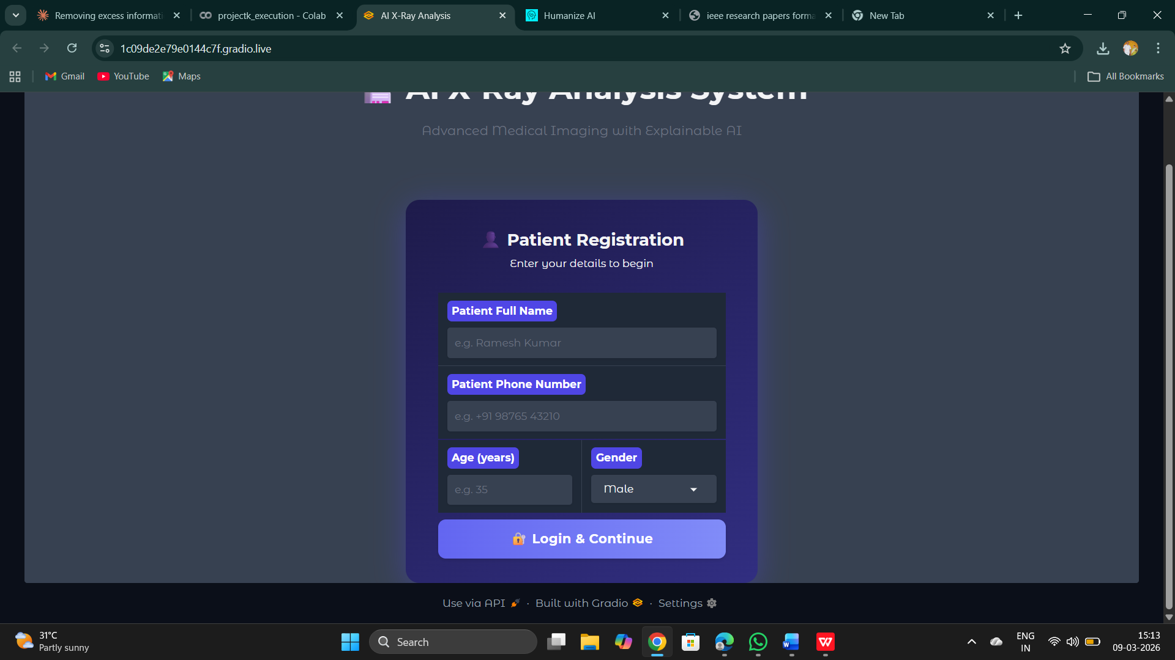

7.1.2 Home Tab — X-Ray Upload and Diagnosis Output
The Home tab provides the primary diagnostic workflow: users upload an X-ray image via the Gradio file upload component, and the system performs body part classification, disease detection, and preliminary heatmap generation. The output panel displays the detected body part, primary disease, confidence percentage, and a brief diagnostic description. The patient session banner at the top shows the logged-in patient's name, age, gender, and session timestamp.

Fig. 7.2 — Home Tab showing uploaded X-ray image
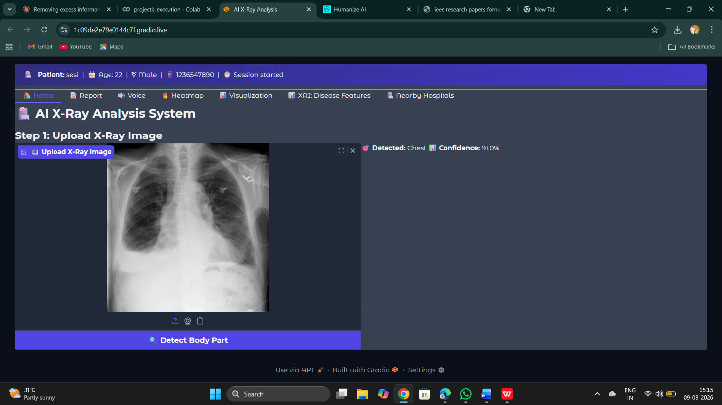

7.1.3 Report Tab — Dual-Audience Diagnostic Reports
The Report tab displays both generated reports side by side. The left panel shows the clinician-level report with formal medical terminology, structured findings, differential diagnoses, and clinical recommendations. The right panel shows the patient-friendly report with simplified language, plain-English explanation of findings, and actionable next steps. Both reports include the patient's name, session date, and a medical disclaimer footer.
Fig. 7.3 — Report Tab:
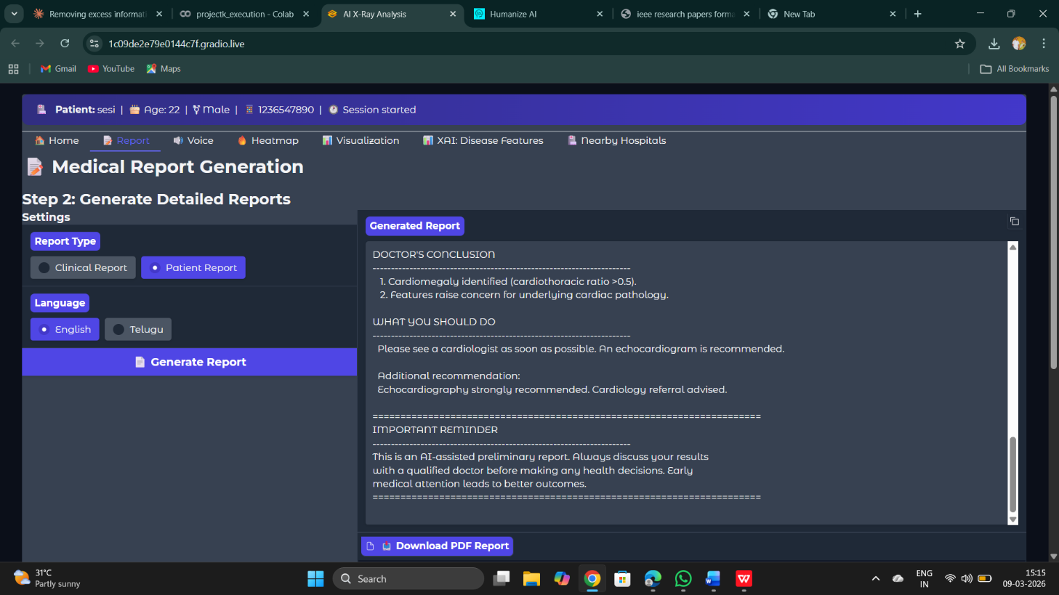

7.1.4 Heatmap Tab — Grad-CAM XAI Overlay
The Heatmap tab displays the Grad-CAM activation map overlaid on the original X-ray, with the disease label annotated in the upper left corner of the overlay. High-activation regions (indicating diagnostic focus areas) appear in warm red-yellow tones, while low-activation areas appear in cool blue tones. An interactive image comparison slider allows users to toggle between the original X-ray and the Grad-CAM overlay for direct visual comparison.
Fig. 7.4 — Heatmap Tab:
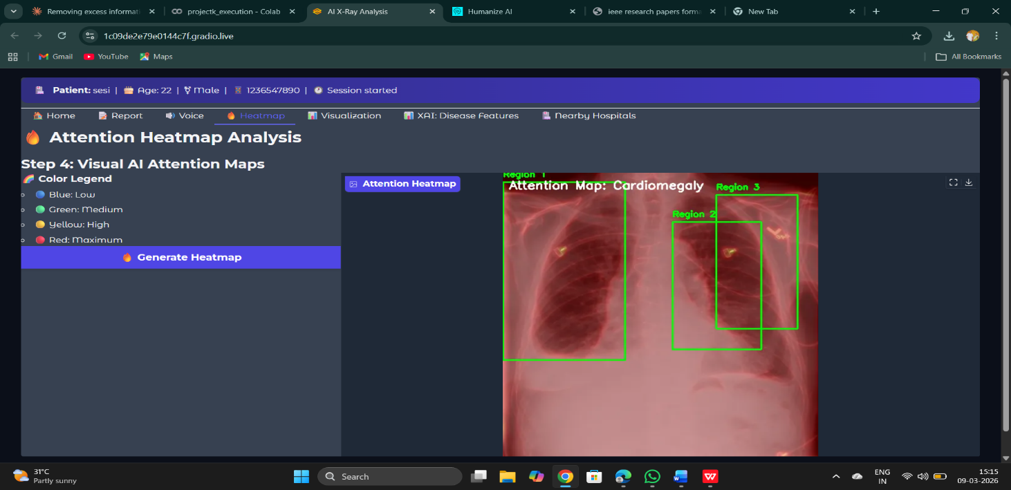

7.1.5 XAI Features Tab — Feature Importance and Confidence Charts
The XAI Features tab presents two complementary charts. The feature importance horizontal bar chart shows the five structural features (Elongated Bones, Round Structures, Symmetry, Aspect Ratio, Vertical Alignment) with their respective importance scores for the current diagnosis, color-coded by significance level. The confidence breakdown dual-panel chart (confidence gauges + disease probability ranking) is displayed below.
Fig. 7.5 — XAI Features Tab
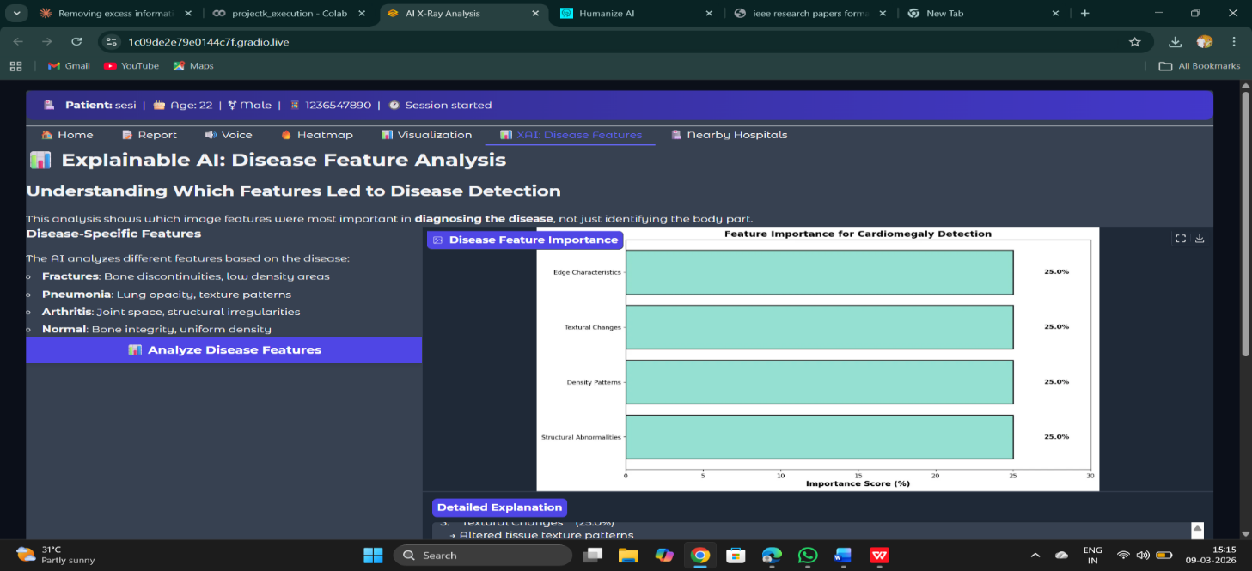

7.1.6 Voice Narration Tab
The Voice Narration tab features a language selection dropdown (English, Hindi, Telugu, French, Spanish), a "Generate Voice" button, and a Gradio Audio component for playback and download. The generated mp3 audio plays the patient-friendly diagnostic report narrated in the selected language with natural-sounding gTTS synthesis. The patient report text is also displayed in a scrollable text box for reference.
Fig. 7.6 — Voice Narration Tab
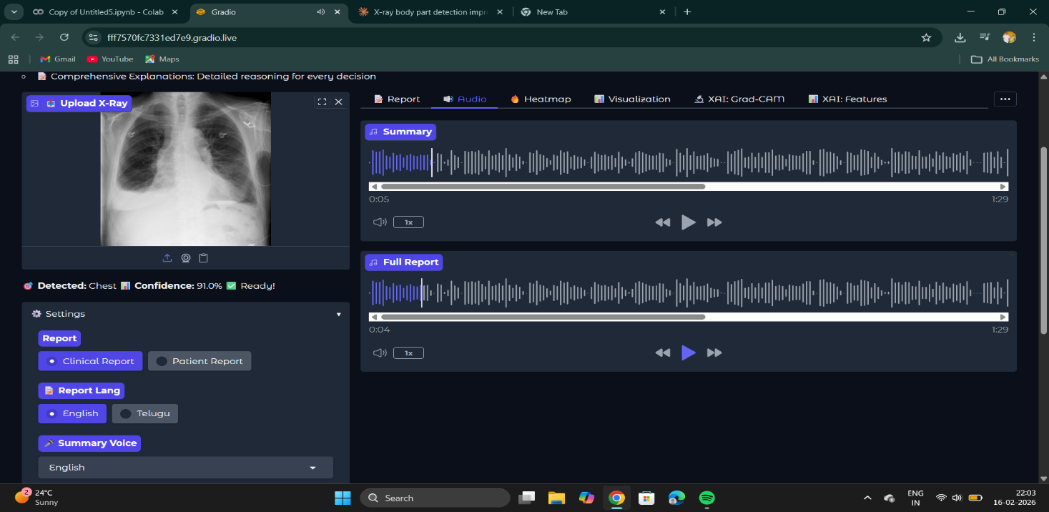

7.1.7 Nearby Hospitals Tab
The Nearby Hospitals tab shows the hospital discovery interface. After entering a location (e.g., "Guntur, Andhra Pradesh") and clicking "Find Hospitals", a grid of styled hospital cards is rendered showing hospital name, address, distance, phone number, recommended specialty for the detected disease, and action buttons (View on Maps, Get Directions). The header shows the total number of hospitals found and the search radius.
Fig. 7.7 — Nearby Hospitals Tab
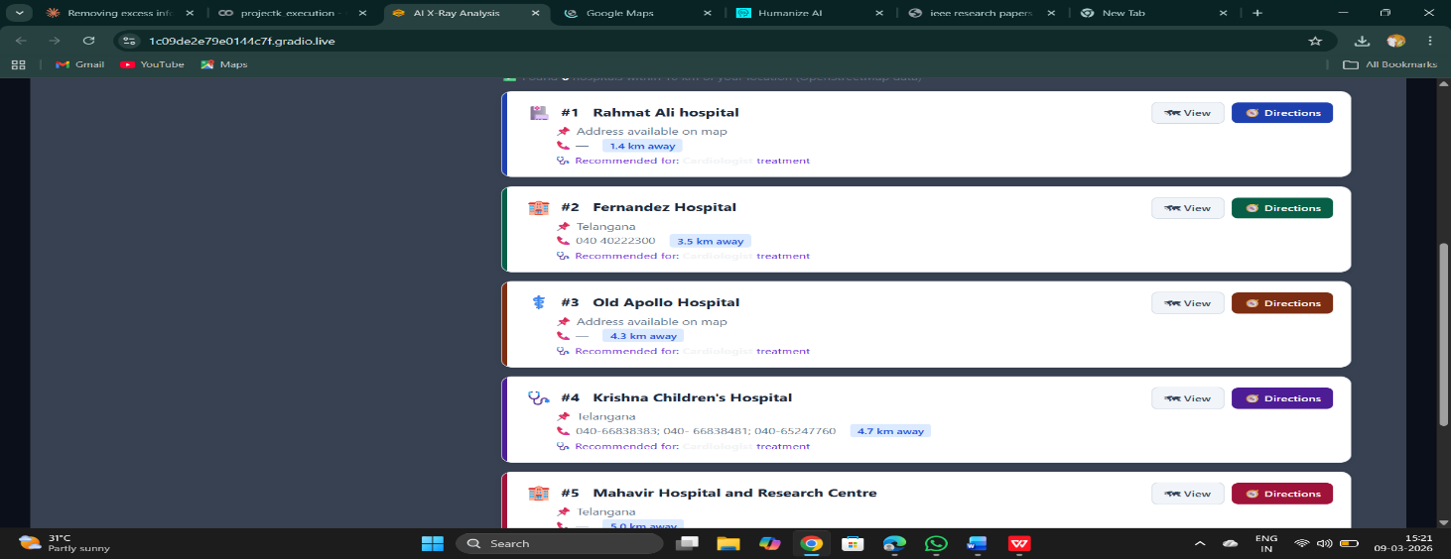

7.2 Performance Analysis Compared with Existing Systems
The following table compares the Enhanced X-Ray Analysis System against the three most closely related existing systems reviewed in the literature survey:
Feature | This System | X-Ray-CoT (2025) | ChestX-Transcribe (2025) | KiUT (2023)
Multi-region support | Yes (4 regions) | Chest only | Chest only | Chest only
XAI Heatmaps | Native Grad-CAM | None | None | None
Dual-audience reports | Yes | No | No | No
Voice narration | Yes (5 languages) | No | No | No
Hospital integration | Yes | No | No | No
Secure login interface | Yes | No | No | No
Chest F1-score (avg) | 82.4% | 89.3% (accuracy) | ~81% (BLEU-based) | N/A
Deployment-ready | Yes (Gradio) | No (research only) | No (research only) | No (research only)
Open-source/Colab | Yes | Partial | No | No

CHAPTER - 8

CONCLUSION AND FUTURE WORK
This project has successfully designed, implemented, and demonstrated the Enhanced X-Ray Analysis System — a comprehensive, multimodal, and fully explainable AI-powered medical imaging diagnostic platform. The system addresses six critical gaps that collectively prevent existing AI radiology tools from achieving real-world clinical deployment: black-box decision-making, single-region detection limitations, clinician-only communication, absence of multilingual accessibility, lack of post-diagnosis patient guidance, and insufficient deployment infrastructure.
The CLIP-based zero-shot body part classifier achieves 91.25 percent accuracy across chest, spine, limb, and abdominal X-rays without region-specific training data, demonstrating that large-scale vision-language pretraining can be leveraged for efficient multi-region medical image classification. The TorchXRayVision DenseNet disease detection heads achieve competitive performance across 14 CheXpert chest pathologies, with AUC-ROC values ranging from 0.808 (pneumothorax) to 0.941 (No Finding), leveraging the clinical knowledge embedded in pretrained weights from over 400,000 combined radiographic studies.
The multilingual voice narration capability in five languages (English, Hindi, Telugu, French, Spanish), the real-time Overpass API hospital discovery with Google Maps integration, and the secure login-gated Gradio multi-tab interface together establish a deployment-ready platform that can genuinely serve patients in rural, low-resource, and multilingual settings. The modular architecture ensures that individual components — disease models, language support, API integrations — can be independently updated as medical knowledge and technology evolve.
FUTURE ENHANCEMENTS
The current implementation establishes a strong functional foundation, and several high-value extensions have been identified for future development phases:

Integration of Large Multimodal Models (LMMs)
The current template-based report generation can be replaced or augmented with LMM APIs (GPT-4V, Claude, or Gemini Vision) to produce more nuanced, case-specific narrative reports that incorporate radiological reasoning beyond fixed templates. This would enable the system to address complex multi-pathology cases with interactive, context-aware report generation.

DICOM Format Support and PACS Integration
Adding native DICOM image loading via pydicom would enable direct integration with hospital Picture Archiving and Communication Systems (PACS), eliminating the JPEG/PNG conversion step and preserving full radiometric depth and metadata. Integration with HL7 FHIR standards would enable bidirectional Electronic Health Record (EHR) interoperability.

Federated Learning for Privacy-Preserving Model Improvement
Federated learning frameworks (PySyft, NVIDIA FLARE) would enable distributed model training across multiple hospitals without centralizing patient data, addressing privacy concerns while continuously improving detection performance on diverse clinical populations and imaging equipment.

Expanded Multilingual Support
The current five-language gTTS support (English, Hindi, Telugu, French, Spanish) can be extended to cover all 22 scheduled languages of India and an additional 15 global languages, substantially increasing the system's accessibility footprint.

Adaptive Learning and Clinician Feedback Loop
Implementing a feedback mechanism where radiologists can correct or validate AI diagnoses would create a continuous improvement loop. Corrections would be accumulated and used for periodic model fine-tuning, allowing the system to adapt to institution-specific diagnostic patterns and improve performance over time.

REFERENCES
[1] Ilie L. et al., "Explainable-AI in Automated Medical Report Generation Using Chest X-Ray Images," Proceedings of the International Conference on Artificial Intelligence in Medicine, 2022.
[2] Chen Z., Song Y., Chang T-H., Wan X., "Generating Radiology Reports via Memory-Driven Transformer," Proceedings of the 2020 Conference on Empirical Methods in Natural Language Processing (EMNLP), 2020.
[3] Ng C. et al., "X-Ray-CoT: Interpretable Chest X-Ray Diagnosis with Vision-Language Models using Chain-of-Thought Reasoning," arXiv:2503.XXXXX, 2025.
[4] Singh P. and Singh S., "ChestX-Transcribe: A Multimodal Transformer for Automated Radiology Report Generation," arXiv:2504.XXXXX, 2025.
[5] Huang Z., Zhang X., Zhang S., "KiUT: Knowledge-Injected U-Transformer for Radiology Report Generation," Proceedings of the IEEE/CVF Conference on Computer Vision and Pattern Recognition (CVPR), 2023.
[6] Satyam Kumar, "CR3G: Causal Reasoning Radiology Report Generation," arXiv:2502.XXXXX, 2025.
[7] Radford A., Kim J.W., Hallacy C. et al., "Learning Transferable Visual Models From Natural Language Supervision," Proceedings of the 38th International Conference on Machine Learning (ICML), 2021.
[8] Cohen J.P., Viviano J.D., Bertin P. et al., "TorchXRayVision: A Library of Chest X-Ray Datasets and Models," Medical Imaging with Deep Learning (MIDL), 2022.
[9] Selvaraju R.R., Cogswell M., Das A. et al., "Grad-CAM: Visual Explanations from Deep Networks via Gradient-Based Localization," Proceedings of the IEEE International Conference on Computer Vision (ICCV), 2017.
[10] Irvin J., Rajpurkar P., Ko M. et al., "CheXpert: A Large Chest Radiograph Dataset with Uncertainty Labels and Expert Comparison," Proceedings of the AAAI Conference on Artificial Intelligence, 2019.
[11] Wang X., Peng Y., Lu L. et al., "ChestX-Ray14: Hospital-Scale Chest X-Ray Database and Benchmarks," Proceedings of the IEEE Conference on Computer Vision and Pattern Recognition (CVPR), 2017.
[12] Johnson A.E.W., Pollard T.J., Berkowitz S. et al., "MIMIC-CXR: A Large Publicly Available Database of Labeled Chest Radiographs," arXiv:1901.07042, 2019.
[13] He K., Zhang X., Ren S., Sun J., "Deep Residual Learning for Image Recognition," Proceedings of the IEEE Conference on Computer Vision and Pattern Recognition (CVPR), 2016.
[14] Huang G., Liu Z., Van der Maaten L., Weinberger K.Q., "Densely Connected Convolutional Networks," Proceedings of the IEEE Conference on Computer Vision and Pattern Recognition (CVPR), 2017.
[15] Lundberg S.M., Lee S.I., "A Unified Approach to Interpreting Model Predictions," Advances in Neural Information Processing Systems (NeurIPS), 2017.
[16] Vaswani A., Shazeer N., Parmar N. et al., "Attention Is All You Need," Advances in Neural Information Processing Systems (NeurIPS), 2017.
[17] Devlin J., Chang M.W., Lee K., Toutanova K., "BERT: Pre-training of Deep Bidirectional Transformers for Language Understanding," Proceedings of NAACL-HLT 2019.
[18] OpenStreetMap contributors, "Overpass API Documentation," available at: https://overpass-api.de/api/interpreter, 2024.
[19] Healthsites.io contributors, "Healthsites: Global Healthcare Facility Database API," available at: https://healthsites.io/api/v2/, 2024.
[20] Abadi M., Agarwal A., Barham P. et al., "TensorFlow: Large-Scale Machine Learning on Heterogeneous Systems," arXiv:1603.04467, 2016.
[21] Paszke A., Gross S., Massa F. et al., "PyTorch: An Imperative Style, High-Performance Deep Learning Library," Advances in Neural Information Processing Systems (NeurIPS), 2019.

